UNIVERSITY OF LONDON
INTERNATIONAL PROGRAMMES

BSc Computer Science and Related Subjects



CM3010 DATABASES & ADVANCED DATA TECHNIQUES
MIDTERM COURSEWORK

Singapore Urban Mobility:

Analysis of Transportation, Housing, and Employment Patterns

Author : Devon Maya Xavior
UOL Student Number : 200618744
SIM Student Number : 10204322

Table of Contents
1. INTRODUCTION 3
2. Purpose 3
3. DATASET ANALYSIS AND CRITIQUE 3
3.1 DATASET OVERVIEW 3
3.2 Dataset Assessment 4
3.2.1 Quality & Level of Detail 4
3.2.2 Documentation 4
3.2.3 Interrelation 4
3.2.4 Terms of Use & Discoverability 4
3.3 Interest and Research Questions Justification 5
4. DATA MODELING 5
4.1 Entity-Relational (E/R) Model 5
4.1.1 RAW Denormalized Model (0NF) to 1NF/2NF 5
4.1.2 Third Normal Form (3NF) 7
4.1.3 Cardinality Analysis 8
5. DATABASE IMPLEMENTATION 9
5.1 Database Creation 9
5.1.1 CREATE TABLE Statements 9
5.1.2 Data Loading Process 10
5.1.3 How well the database reflects data 10
5.2 Query Development 10
5.2.1 Research Question 1 Query Sample 10
5.2.2 Research Question 2 Query Sample 11
5.2.3 Research Question 3 Query Sample 11
5.3 Limitations 12
6. WEB APPLICATION 12
7. CONCLUSION 14
APPENDICES 15
Appendix A: Data source information 15
Dataset 1: Transportation and Area of Residence 15
Dataset 2: Residential Area and Housing Type Analysis 15
Dataset 3: Workplace-Residence Patterns 15
Appendix B: Data-use License 15
Appendix C: Raw data samples 16
Appendix D: CREATE Commands 17
Appendix E: Data Loading Commands 19
Appendix F: Web Application 20
REFERENCES 23
CODE 23
SQL 23
Web Application 39

1. INTRODUCTION
Singapore’s urban planning is known for its efficiency, driven by the careful integration of transport, housing, and employment. This project initially set out to identify ideal locations for EV chargers across the city but uncovered a key information gap: the lack of data linking the geographical distribution of residents to existing car ownership and EV charging infrastructure. In response, the study shifted focus to examine patterns in how residents are distributed across Singapore—specifically the relationships between their modes of transport to work, areas of residence, occupations, and housing types. These insights will help build a stronger data foundation for potential future analysis on optimally locating EV chargers based on distribution of the population with reference to the aforementioned factors.

2. Purpose
The primary purpose of this database project is to investigate Singapore's transportation and residential patterns by addressing the following research questions:
- Transportation patterns across residential planning areas?
This analysis explores how residents’ transportation preferences vary by planning area, highlighting mobility patterns and infrastructure accessibility across Singapore.
- Influence of dwelling types and residential density on transportation choices?
This analysis investigates how housing characteristics (e.g., HDB flats vs. private housing, residential density) correlate with transportation mode preferences.
- Commuting patterns by workplace location and occupation categories?
This examines commuting behaviours across occupational groups and workplace locations to give more information on patterns between transportation infrastructure and employment hubs.

3. DATASET ANALYSIS AND CRITIQUE

3.1 DATASET OVERVIEW
This study utilizes three complementary multi-dimensional datasets from Singapore's Census of Population 2020, published by the Department of Statistics.
- Employed Residents Aged 15 Years and Over by Planning Area of Residence and Usual Mode of Transport to Work (Census of Population 2020)
- Resident Population by Planning Area/Subzone of Residence and Type of Dwelling (Census of Population 2020)
- Employed Residents Aged 15 Years and Over by Planning Area of Workplace and Occupation (Census of Population 2020)

3.2 Dataset Assessment

3.2.1 Quality & Level of Detail
Singapore adopts a systematic approach to national data collection, conducting a full Census of Population every ten years (e.g., 2010, 2020, 2030) and a General Household Survey midway between censuses every five years (e.g., 2015, 2025). The most recent dataset, the 2020 Census, offers comprehensive and detailed demographic insights, particularly into mobility patterns related to commuting for work and education. While data on other transportation purposes is less extensive, the dataset still provides enough detail to analyse travel behaviours in relation to residential locations (ranging from larger planning areas to specific subzones), housing types, and job categories. Additionally, the database structure developed through this project can easily incorporate future datasets, supporting continued relevance and thoroughness in transport planning (such as strategically locating EV charging stations).

3.2.2 Documentation

The 2020 Singapore Census of Population used a register-based methodology (Singapore Department of Statistics, 2021) by combining administrative records for basic demographic information with a comprehensive sample survey of approximately 150,000 households to capture more detailed socio-economic and household characteristics.

Data collection was multimodal, allowing respondents to submit census returns online, via telephone interviews, or through face-to-face interviews. Due to the COVID-19 pandemic, adjustments were made, including temporary suspension of fieldwork and adoption of remote working arrangements, with fieldwork resuming in phases.

3.2.3 Interrelation

All three datasets are unified by planning area as their core geographic reference, while the resident population further disaggregates data into subzones. This common framework enables cross-navigation between combinations of factors—transport mode, dwelling type, workplace location, occupation, and residential subzone—so that the research questions outlined in the Purpose section (e.g., how transportation choices vary by planning area, how housing characteristics influence travel mode preferences, and how commuting patterns differ across occupational groups and workplace locations) can be answered comprehensively.

3.2.4 Terms of Use & Discoverability

The datasets retrieved from the Singapore Department of Statistics are “free forever for personal or commercial use, under the Open Data License”. Users can easily browse the data on the SingStat or other government websites, download CSV or XLSX files, and access metadata and methodological notes on the datasets used in this project.

3.3 Interest and Research Questions Justification

I originally planned to leverage the postal code data on an available EV charging stations dataset to identify optimal EV charging locations, but the available data on geographical population distribution only uses general planning areas as their geographical data. To establish a robust foundation for future charging-station planning, I’m focusing on transportation patterns—especially the balance between car use and type of housing—as the primary indicator of local demand. By layering in occupational distributions, this approach reveals areas with strong car dependency, high residential density, and workforce profiles suggestive of EV usage. Centering on these transportation patterns ensures that the eventual placement of EV chargers is driven by real commuting behaviours and community needs, rather than solely by geographical proximity.

4. DATA MODELING

4.1 Entity-Relational (E/R) Model

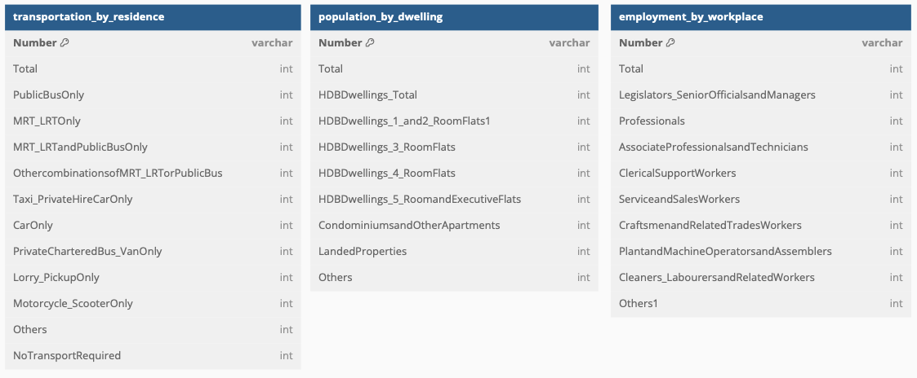
4.1.1 RAW Denormalized Model (0NF) to 1NF/2NF
Although structurally sound, the government datasets needed extensive cleaning to standardize field names (e.g., inserting spaces, renaming “Number” to “planning_area”), recode inconsistent characters (replacing “–” with 0), and split combined planning-area/subzone columns. All preprocessing—renaming, spacing, recoding, and parsing—was done in Python and exported out in new CSV files for data loading in the database.

In its raw form, the dataset consists of wide, flat tables where every transport mode, dwelling type, and occupation category is represented as a separate column. While this layout makes it straightforward to ingest the data, it buries structural logic within the table itself. Any addition or modification—such as introducing a new transport mode—requires altering the schema, and the proliferation of similar columns increases the risk of inconsistent or redundant entries over time.
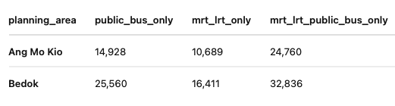

For example, the dataset with the transportation modes has many columns, each representing a count of transportation type; it will be difficult to add new modes (e.g., “e-scooter”) without altering the schema. Also, it may lead to many sparse or zero values when a mode is not used heavily.
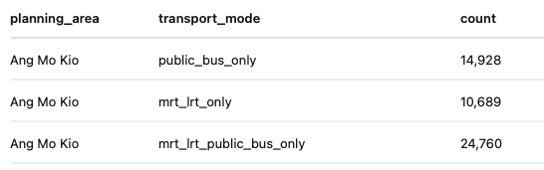

As 1NF requires that each row be atomic and contain only one fact per column, I “unpivot” the transport-mode columns into rows to give just one column called “transport_mode.” A benefit of this layout is that there is atomicity, as each row represents one planning_area + one transport_mode + one count. Also, flexibility is introduced to enable the addition of new transport modes without changing the table structure; new rows just have to be inserted. Queries like “show me counts by mode” become straightforward GROUP BY transport_mode. The same concept is applied to the other datasets as well.

After normalisation to 1NF, the resulting E/R schema is one where each fact table has been reduced to a simple three-column junction model. Every lookup table has a single-column primary key. Each statistics table uses a composite primary key of two foreign keys to prevent accidental duplicates. The following is the 1NF E/R model.

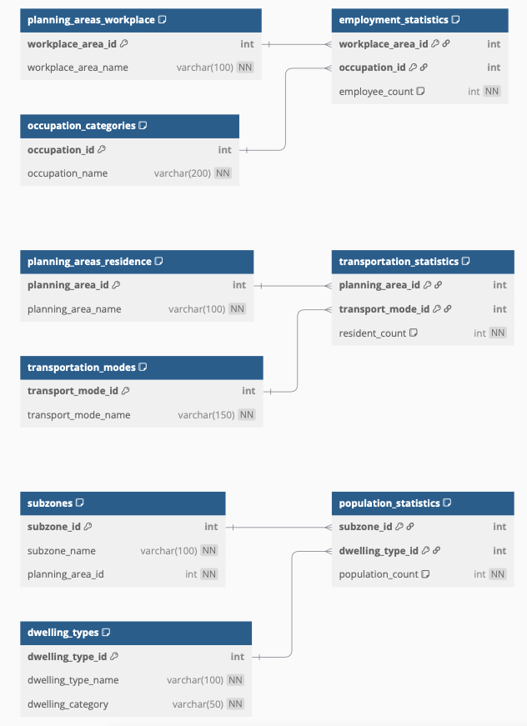

Once in 1NF, we assessed 2NF, which requires every non-key field to depend on the entire primary key. Our junction tables inherently meet this: each count only makes sense when linked to both a planning area and a transport mode. With lookup tables built on single-column keys and statistics tables using composite keys, no partial dependencies exist. In short, our 1NF design already satisfies 2NF without additional changes.

4.1.2 Third Normal Form (3NF)

In the 3NF review, I spotted a transitive dependency in dwelling_types: the category (dwelling_category) was derived from the dwelling name rather than the table’s primary key. To fix this, I split it into two tables—dwelling_categories (holding each unique category) and a trimmed-down dwelling_types that simply points to its category by foreign key. This change removes redundancy, avoids update errors, and guarantees every attribute now depends directly on its own primary key. All the other tables already had only direct key-to-attribute relationships, so with this adjustment, the entire schema meets Third Normal Form.
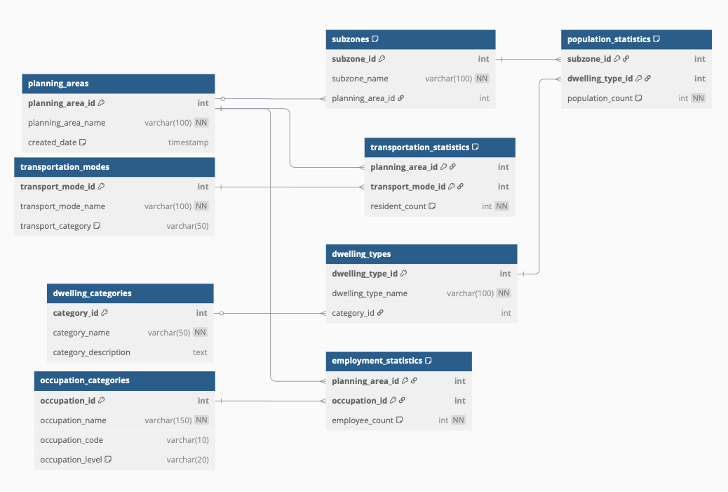

4.1.3 Cardinality Analysis

One-to-Many Hierarchies

The schema captures Singapore’s dwelling classification through clear one-to-many relationships. In the planning areas → subzones hierarchy, each planning area can encompass multiple subzones, enforced by a foreign key in the subzones table. Likewise, dwelling categories (for example, “HDB Dwellings”) reside in their own table, with each specific flat type linked by a foreign key in dwelling_types. This separation removed the earlier transitive dependency and keeps each table focused on a single concept.

Many-to-Many Connections

Complex overlaps—where residents in multiple planning areas use various transport modes, workplaces employ different occupations, and subzones feature diverse dwelling types—are all managed via junction tables. The transportation_statistics, employment_statistics, and population_statistics tables each use a composite primary key (the two related IDs) plus a count column. This pattern preserves atomicity, eliminates repeated columns, and retains the essential intersection data (resident, employee, or population counts) needed for analysis.

All foreign keys are explicitly declared, and every attribute depends directly on its table’s primary key. There are no nested or multi-valued fields, no repeating groups, and no transitive dependencies outside of the one corrected.

5. DATABASE IMPLEMENTATION

5.1 Database Creation

5.1.1 CREATE TABLE Statements

There are 9 CREATE commands used for the core lookup tables and 3 CREATE commands used for the raw data staging tables.

 | Core Lookup Tables | Raw Staging Tables
 | planning_areas | raw_transportation
 | transportation_modes | raw_population
 | dwelling_categories | raw_employment
 | occupation_categories
 | subzones
 | dwelling_types
 | transportation_statistics
 | population_statistics
 | employment_statistics

It is simple and consistent across the lookup tables. Each table uses a stable, auto-incrementing ID (like planning_area_id or occupation_id), so records stay uniquely identified even if their names change. In the planning areas table, a created_date timestamp was added to know exactly when each area was added. Unique constraints are applied on names and codes—be it a planning area name, transport mode name, category name, occupation name, or occupation code—so there is no risk with duplicates. At the same time, optional fields like category_description and occupation_level can capture extra details without forcing every record to fill in every column. Altogether, this setup guarantees data integrity while keeping the schema flexible and easy to maintain.

Before transforming the data, the original CSVs of the datasets are loaded into raw staging tables—raw_transportation, raw_population, and raw_employment—that match the files’ original wide formats. By keeping every column exactly as it appears (think mrt_lrt_public_bus_only or hdb_dwellings_1_and_2_room_flats), data can be imported and checked without losing any context. This step allows validation and cleaning of the untouched data, all while keeping a clear link back to the source, before breaking it down into the normalized tables.

5.1.2 Data Loading Process

The CSVs of the datasets are bulk-imported into the staging tables with the LOAD DATA INFILE command. Settings are placed to ensure headers are skipped, values are distinctly recognized, and missing or blank values will not break the load but stay as numbers. This way, the source format is kept intact, and we can catch and fix any data issues before the transformation stage.

5.1.3 How well the database reflects data

By moving the raw counts into junction tables, every statistic is kept exactly as it was—while giving the flexibility to ask new questions. Instead of juggling separate CSVs for transportation, population, and employment, the three domains can be joined by sharing the same planning area or subzone keys. Likewise, pulling the housing categories out of cryptic column names like hdb_dwellings_3_room_flats and into their own tables allows dwelling types to be treated as individual entities, with clear relationships to their broader categories. Questions like comparing car use against high-rise versus landed housing, data for which were from 2 separate datasets, can be explored without losing any of the original population or employee counts. In short, the database allows easy slicing and dicing of all 3 separate datasets while preserving the exact numbers that made the source files valuable in the first place.

5.2 Query Development

5.2.1 Research Question 1 Query Sample
Transportation patterns across residential planning areas?
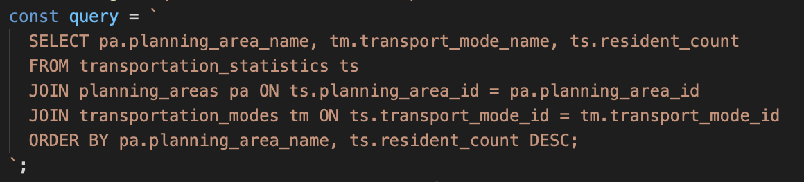

5.2.2 Research Question 2 Query Sample
Influence of dwelling types and residential density on transportation choices?
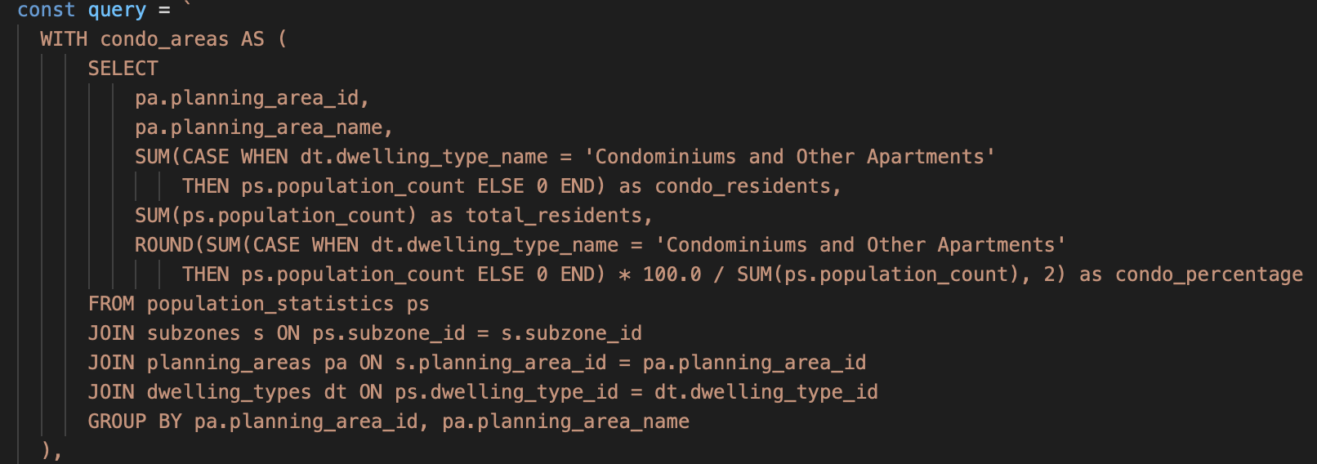
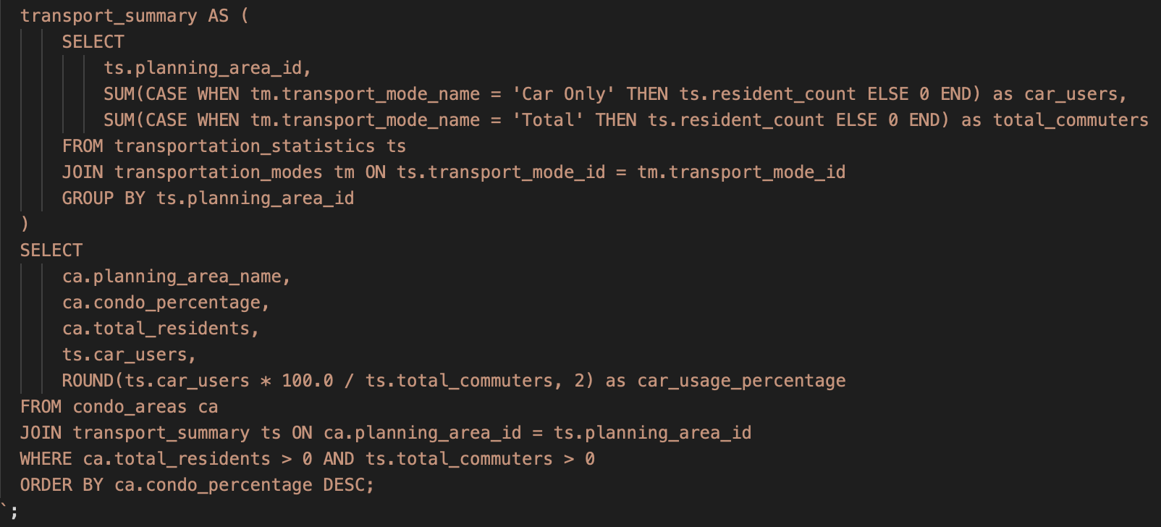

5.2.3 Research Question 3 Query Sample
Commuting patterns by workplace location and occupation categories?

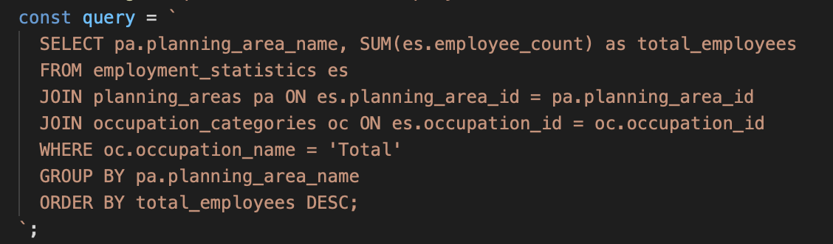

5.3 Limitations

While questions 1 and 2 can be mostly addressed through the query commands, question 3 faces some challenges.

What the database can query:
- Employment distribution by workplace planning area and occupation
- Top employment center area
- Professional vs. Service occupation distribution by workplace
- Transportation demand estimation for major employment center areas

What the database cannot query:
- How people get from home to the workplace
- Where professionals vs. service workers travel
- Multi-area commuting patterns

While employment distribution by workplace and occupation can be analysed, it is hard to examine actual commuting flows or origin-destination transportation patterns due to the missing linkage between residential and workplace planning areas in the current schema design. This is also because such data linkage is not provided in the original raw data and cannot be deduced without the necessary information.

6. WEB APPLICATION
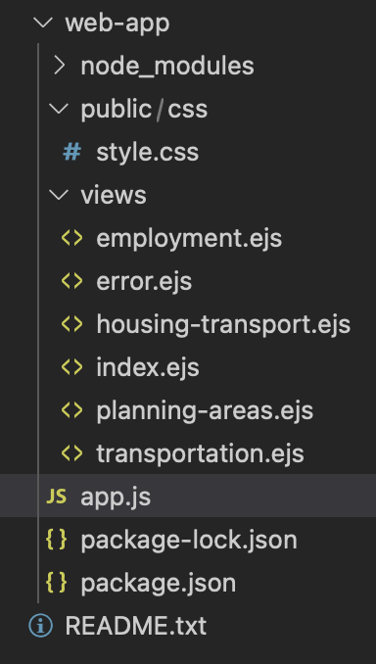
The web application is built on Node.js using Express for the server and EJS for templating. The file app.js configures middleware that establishes the shared MySQL connection and defines all of the route handlers.

Each page of the web application has an EJS template that corresponds to it, i.e., employment.ejs, house-transport.ejs. These pages are reached through the pressing of buttons that are named after each of the 3 finer questions addressed in this project.
The Express routes in app.js execute SQL queries against the normalized MySQL schema, process the results (grouping, percentage calculations, hub classifications), and then pass the final data objects into the EJS renderer. With this clear separation—app.js for server logic, views/ for presentation, and public/ for static assets—the codebase remains organized and ready for any new queries that may come about later.

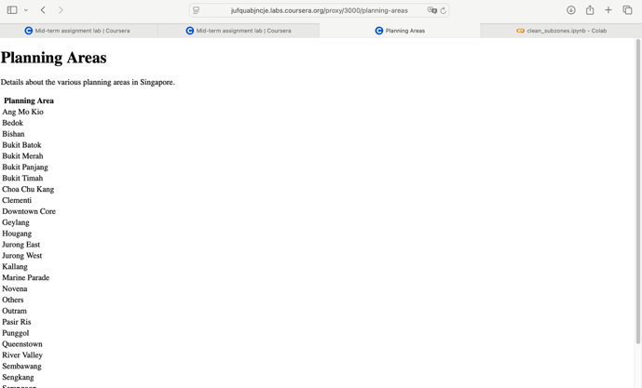
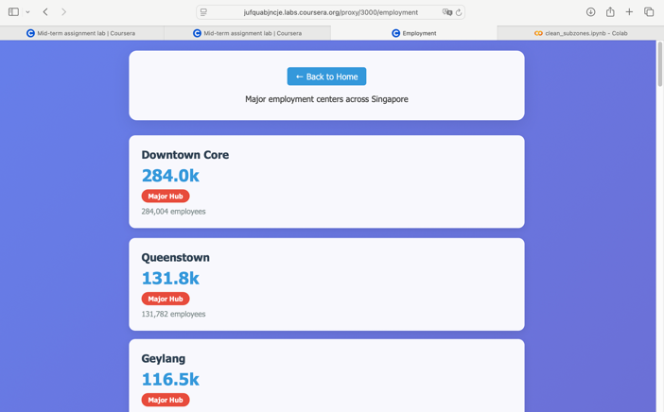
Link:
https://hub.labs.coursera.org:443/connect/sharedldxreijg?forceRefresh=false&path=%2F%3Ffolder%3D%2Fhome%2Fcoder%2Fproject&isLabVersioning=true

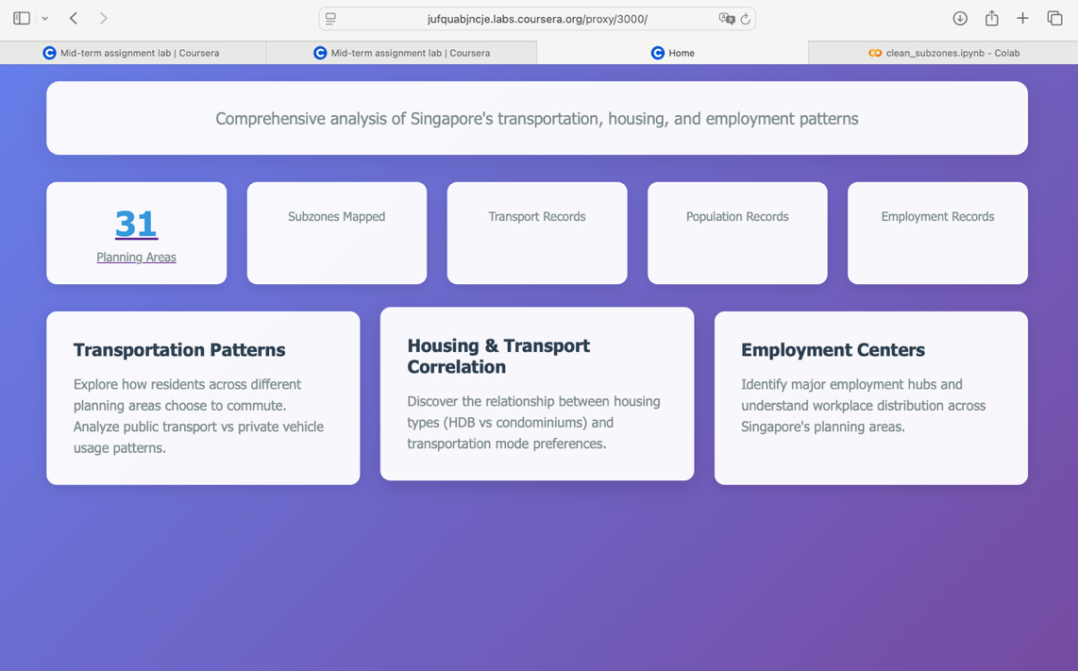

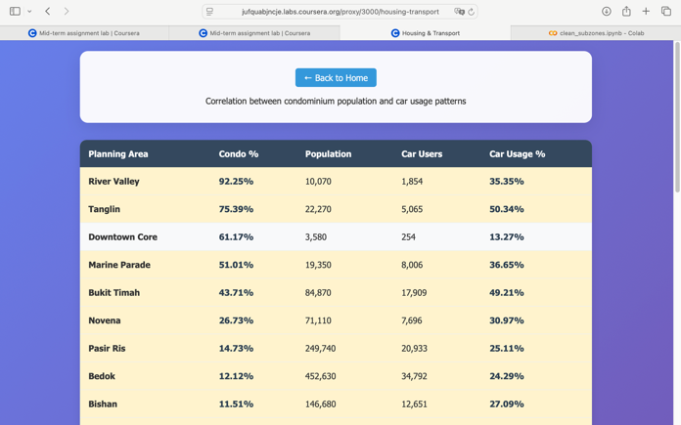
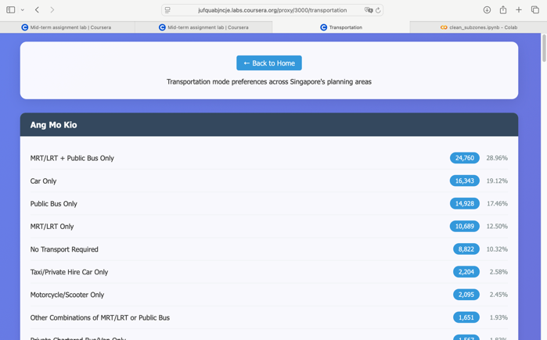

7. CONCLUSION

While the government datasets provided a high degree of reliability and consistency, they limited opportunities to fully explore and apply advanced normalization techniques. In future iterations, I will incorporate non-government data sources, where schema design is more flexible, to rigorously test Second and Third Normal Form processes and achieve finer granularity. As soon as the 2025 General Household Survey is published, I will integrate its transport, housing, and occupational variables into the existing pipeline to validate and extend the findings.

Despite these constraints, this project has been invaluable in demonstrating how to transform raw CSV files into a dynamic, extensible database capable of absorbing new data with minimal rework. The workflow developed has equipped me with practical skills in designing scalable data models. Armed with these lessons and richer datasets ahead, I am well positioned to realize my ultimate objective: producing a data-driven map that identifies the optimal locations for EV charging stations based on real commuting patterns and community needs.

APPENDICES

Appendix A: Data source information

Source: Singapore Department of Statistics
Data Collection: Census of Population 2020
Format: CSV
License: Open Data License (Singapore)
Data Last Updated: 18/06/2021
Update Frequency: 10 years
Notes: Planning areas refer to areas demarcated in the Urban Redevelopment Authority’s Master Plan 2019. Data exclude employed persons who were overseas for more than 6 months.

Dataset 1: Transportation and Area of Residence

Title: Employed Residents Aged 15 Years and Over by Planning Area of Residence and Usual Mode of Transport to Work (Census of Population 2020)
URL: https://data.gov.sg/datasets/d_1f8f5ec7201964e365c77551cab99503/view
Purpose: Primary dataset for analyzing work transportation choices and relation to area of residence.

Dataset 2: Residential Area and Housing Type Analysis

Title: Resident Population by Planning Area/Subzone of Residence and Type of Dwelling (Census of Population 2020)
URL: https://data.gov.sg/datasets/d_7f243956483d5901f237e6f87b096636/view
Purpose: Hierarchical geographic structure with housing type data requiring careful relationship modeling for transportation correlation analysis.

Dataset 3: Workplace-Residence Patterns

Title: Employed Residents Aged 15 Years and Over by Planning Area of Workplace and Occupation (Census of Population 2020)
URL: https://data.gov.sg/datasets/d_a9c214d2534f2da9587ae3bb481f3b85/view
Purpose: Provides workplace location analysis with occupational categorization for understanding commuting patterns and transportation demand across employment centers.

Appendix B: Data-use License



Appendix C: Raw data samples

Title: Employed Residents Aged 15 Years and Over by Planning Area of Residence and Usual Mode of Transport to Work (Census of Population 2020)

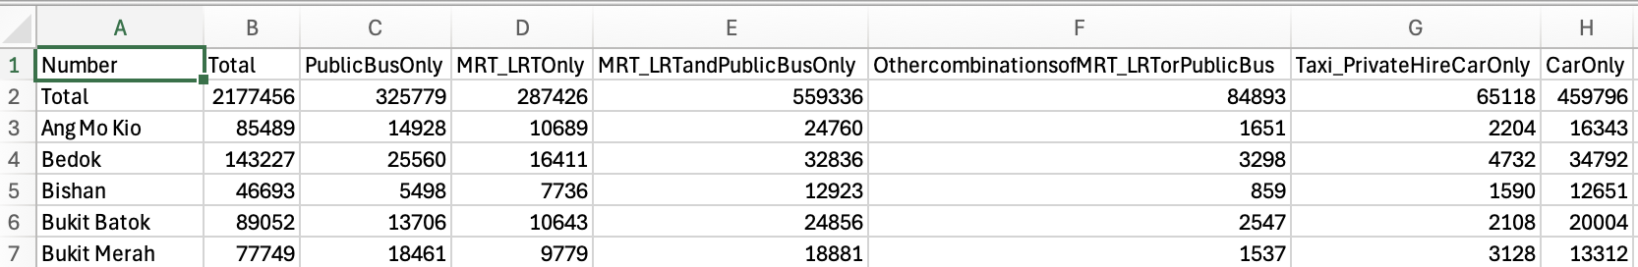

Title: Resident Population by Planning Area/Subzone of Residence and Type of Dwelling (Census of Population 2020)

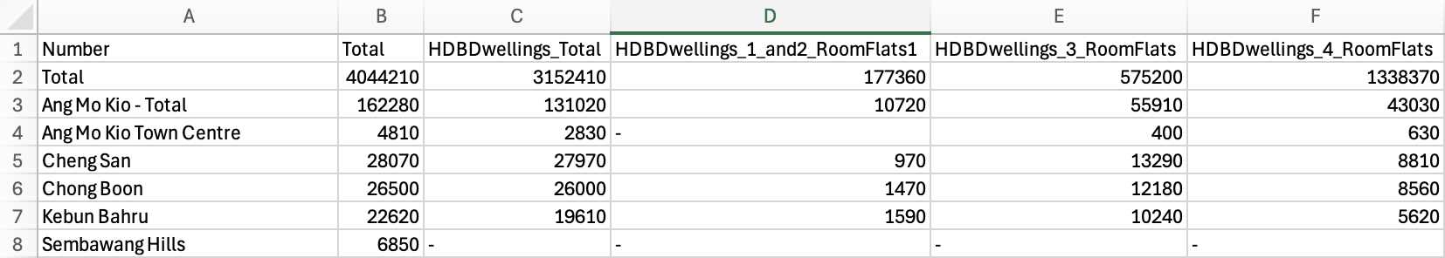

Title: Employed Residents Aged 15 Years and Over by Planning Area of Workplace and Occupation (Census of Population 2020)

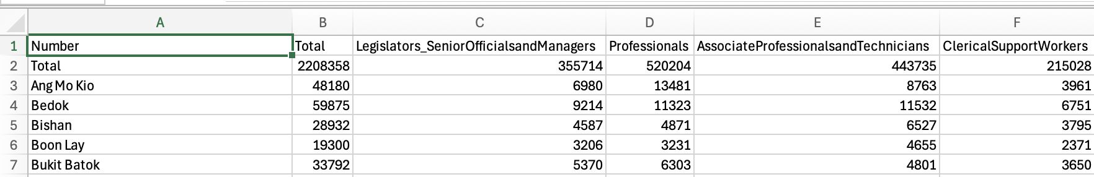

Appendix D: CREATE Commands
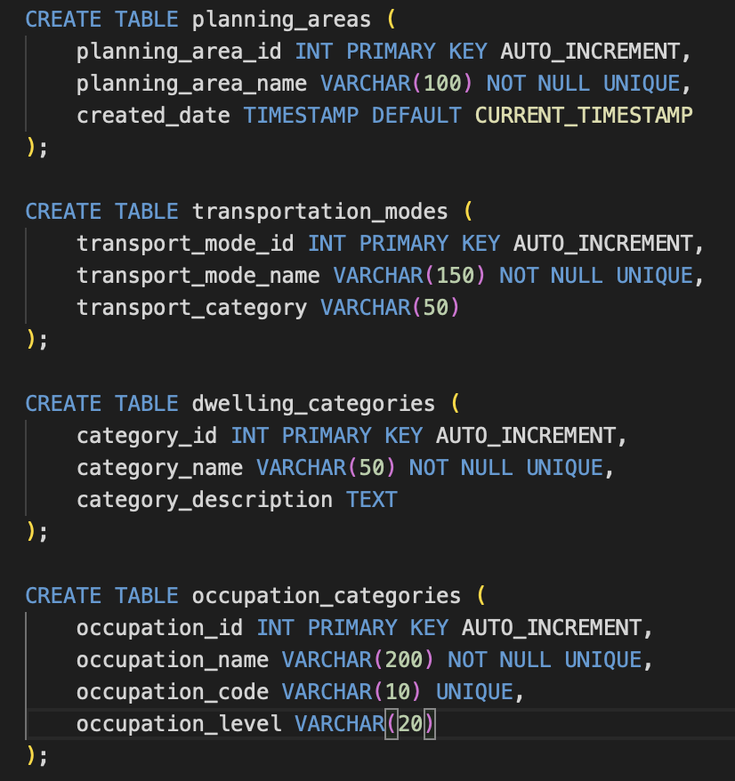

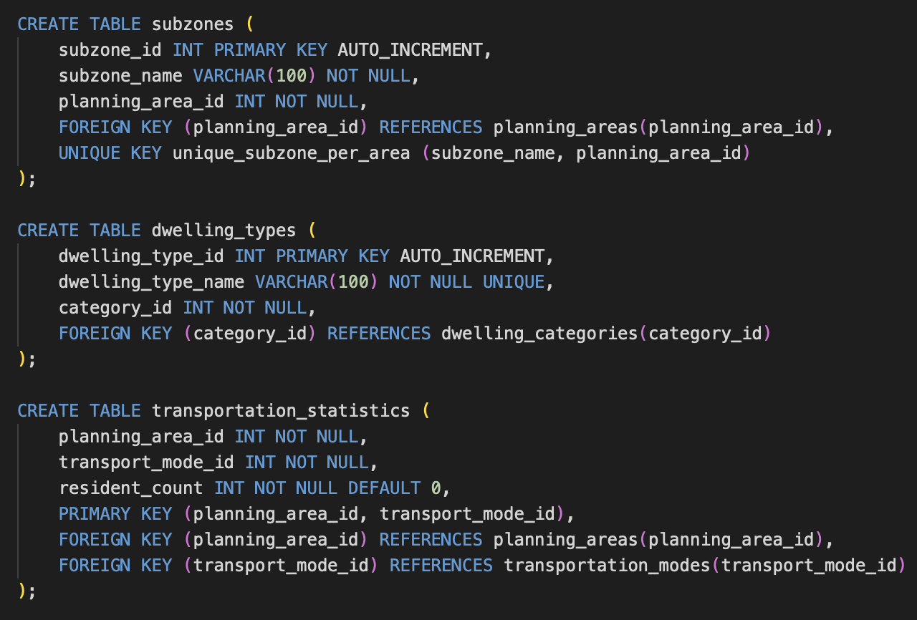

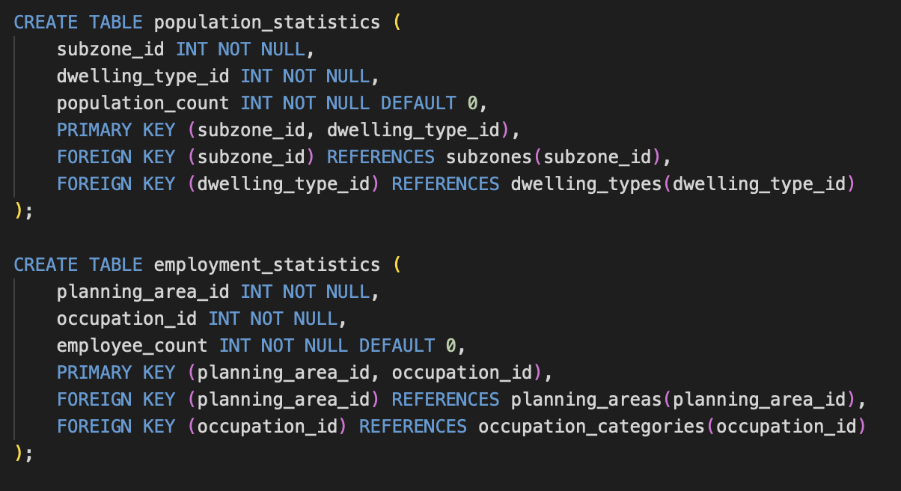

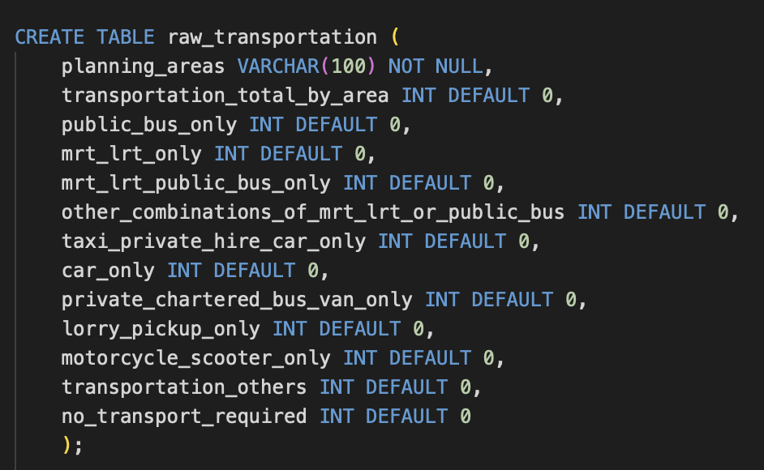
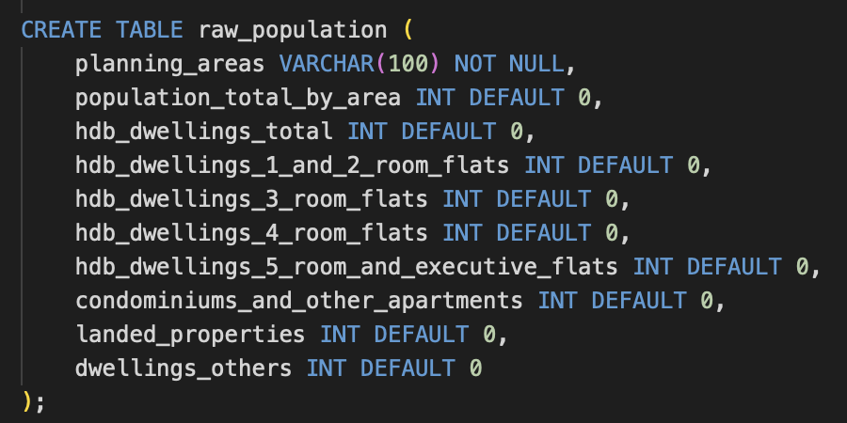
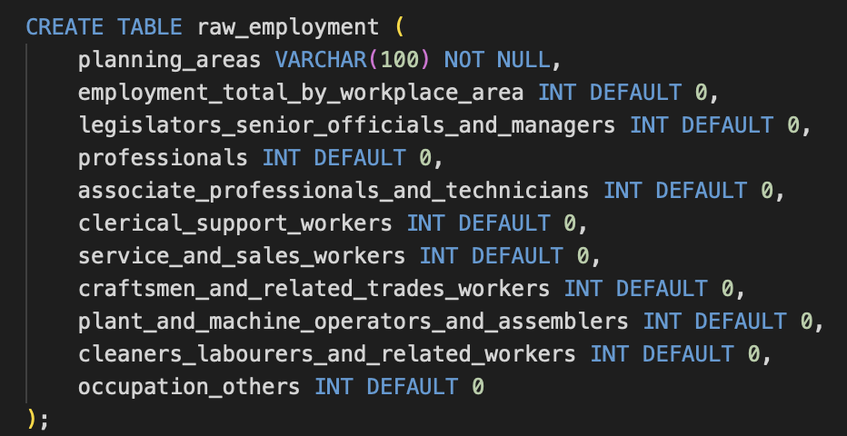

Appendix E: Data Loading Commands

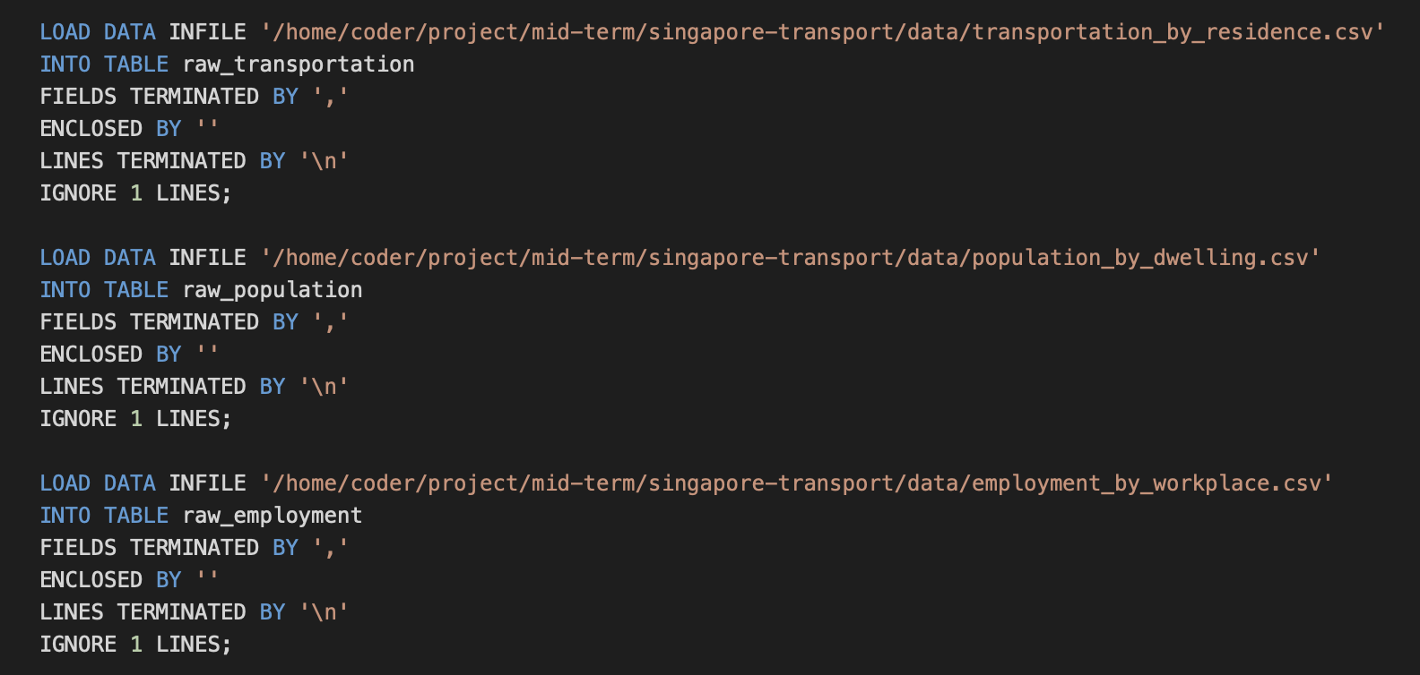

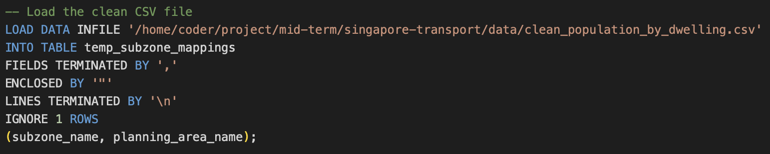

Appendix F: Web Application

Landing Page
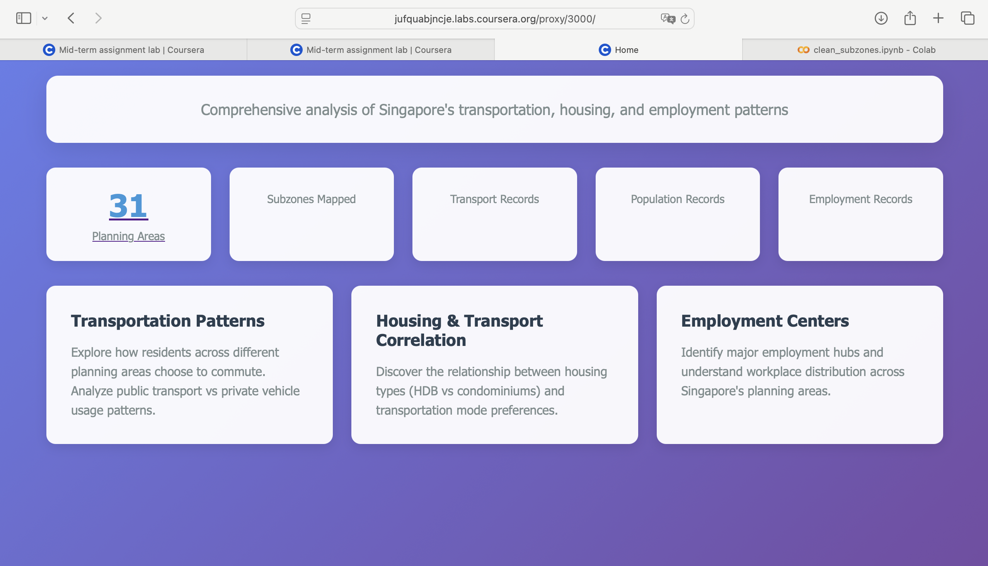


Transportation Patterns

Housing & Transport Correlation
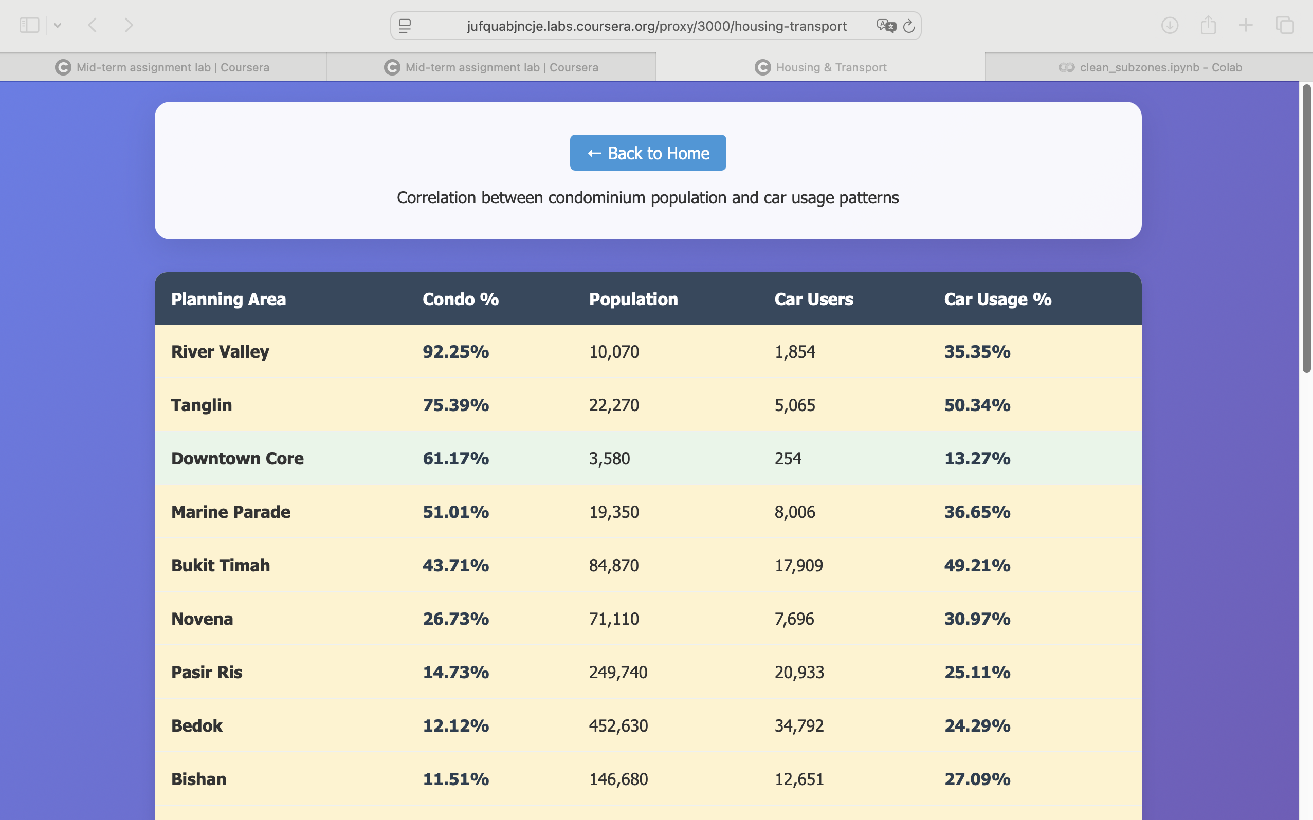

Employment Centers
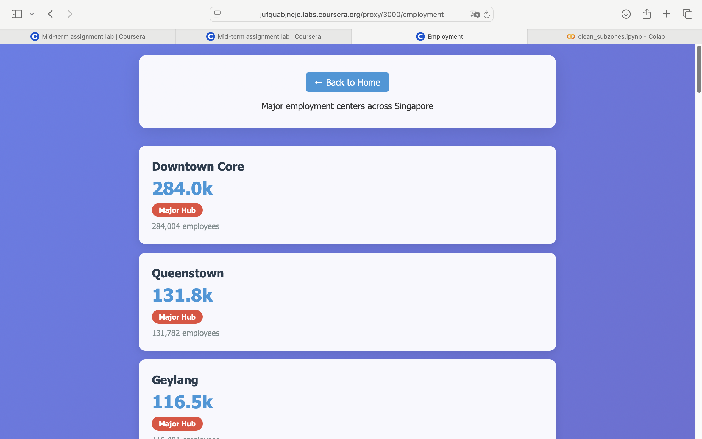

Planning Areas
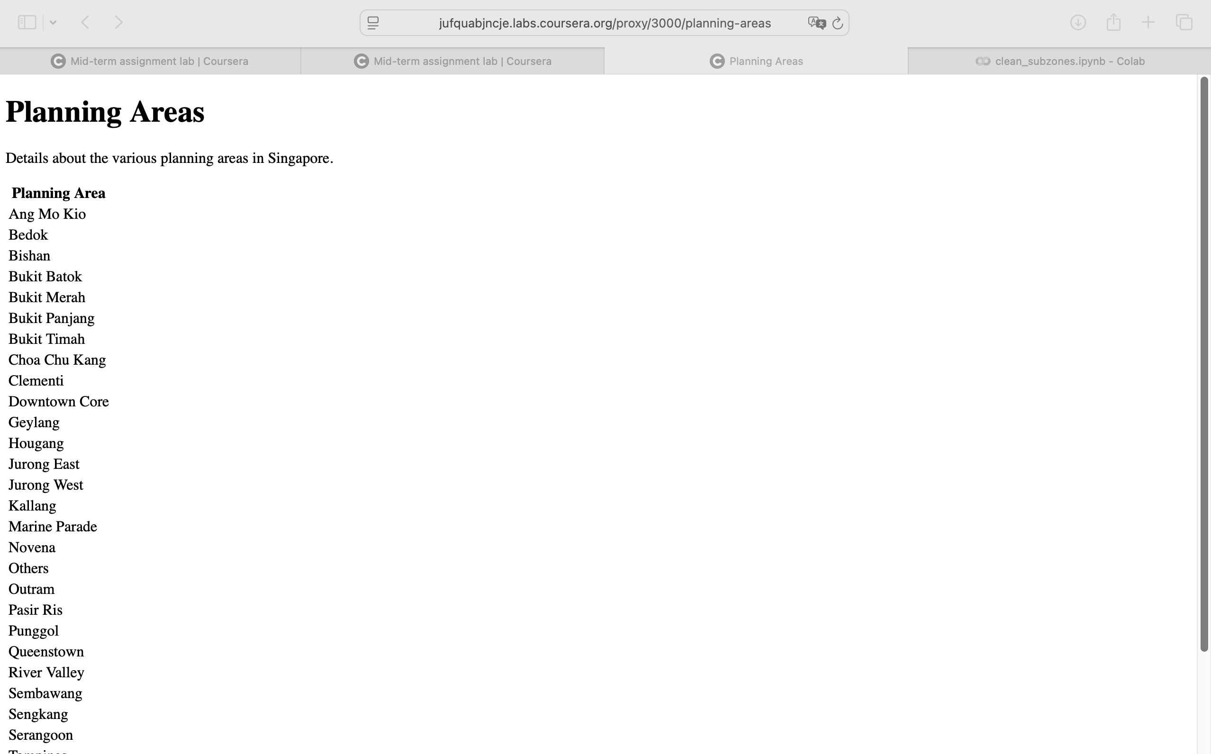

https://hub.labs.coursera.org:443/connect/sharedldxreijg?forceRefresh=false&path=%2F%3Ffolder%3D%2Fhome%2Fcoder%2Fproject&isLabVersioning=true

REFERENCES

Singapore Department of Statistics. (2021). Census of Population 2020 Administrative Report: Chapter 2—Planning and Preparation for Sample Enumeration. Retrieved from https://www.singstat.gov.sg/-/media/files/publications/cop2020/admin/ch2.ashx#:~:text=Census%202020%20adopted%20the%20register,to%20150%2C000%20households%20in%20Singapore.

Singapore Department of Statistics. (2024). Employed Residents Aged 15 Years and Over by Planning Area of Residence and Usual Mode of Transport to Work (Census of Population 2020) (2025) [Dataset]. data.gov.sg. Retrieved from https://data.gov.sg/datasets/d_1f8f5ec7201964e365c77551cab99503/view

Singapore Department of Statistics. (2024). Resident Population by Planning Area/Subzone of Residence and Type of Dwelling (Census of Population 2020) (2025) [Dataset]. data.gov.sg. Retrieved from https://data.gov.sg/datasets/d_7f243956483d5901f237e6f87b096636/view

Singapore Department of Statistics. (2024). Employed Residents Aged 15 Years and Over by Planning Area of Workplace and Occupation (Census of Population 2020) (2025) [Dataset]. data.gov.sg. Retrieved from https://data.gov.sg/datasets/d_a9c214d2534f2da9587ae3bb481f3b85/view

CODE

SQL
## configure-database.sql ## OWN CODE ##

-- Create the database
CREATE DATABASE IF NOT EXISTS singapore_transport_db;

-- Use the database
USE singapore_transport_db;

-- Create user for project
CREATE USER IF NOT EXISTS 'singapore_user'@'localhost' IDENTIFIED BY 'transport123';
CREATE USER IF NOT EXISTS'singapore_user'@'127.0.0.1' IDENTIFIED BY 'your_password';

-- Grant all privileges on database to user
GRANT ALL PRIVILEGES ON singapore_transport_db.* TO 'singapore_user'@'localhost';
GRANT ALL PRIVILEGES ON singapore_transport_db.* TO 'singapore_user'@'127.0.0.1';

-- Flush privileges
FLUSH PRIVILEGES;

-- Show Existing Databases
SHOW DATABASES;
SELECT user, host FROM mysql.user WHERE user = 'singapore_user';

## create-data-tables.sql ## OWN CODE ##
CREATE TABLE planning_areas (
planning_area_id INT PRIMARY KEY AUTO_INCREMENT,
planning_area_name VARCHAR(100) NOT NULL UNIQUE,
created_date TIMESTAMP DEFAULT CURRENT_TIMESTAMP
);

CREATE TABLE transportation_modes (
transport_mode_id INT PRIMARY KEY AUTO_INCREMENT,
transport_mode_name VARCHAR(150) NOT NULL UNIQUE,
transport_category VARCHAR(50)
);

CREATE TABLE dwelling_categories (
category_id INT PRIMARY KEY AUTO_INCREMENT,
category_name VARCHAR(50) NOT NULL UNIQUE,
category_description TEXT
);

CREATE TABLE occupation_categories (
occupation_id INT PRIMARY KEY AUTO_INCREMENT,
occupation_name VARCHAR(200) NOT NULL UNIQUE,
occupation_code VARCHAR(10) UNIQUE,
occupation_level VARCHAR(20)
);

CREATE TABLE subzones (
subzone_id INT PRIMARY KEY AUTO_INCREMENT,
subzone_name VARCHAR(100) NOT NULL,
planning_area_id INT NOT NULL,
FOREIGN KEY (planning_area_id) REFERENCES planning_areas(planning_area_id),
UNIQUE KEY unique_subzone_per_area (subzone_name, planning_area_id)
);

CREATE TABLE dwelling_types (
dwelling_type_id INT PRIMARY KEY AUTO_INCREMENT,
dwelling_type_name VARCHAR(100) NOT NULL UNIQUE,
category_id INT NOT NULL,
FOREIGN KEY (category_id) REFERENCES dwelling_categories(category_id)
);

CREATE TABLE transportation_statistics (
planning_area_id INT NOT NULL,
transport_mode_id INT NOT NULL,
resident_count INT NOT NULL DEFAULT 0,
PRIMARY KEY (planning_area_id, transport_mode_id),
FOREIGN KEY (planning_area_id) REFERENCES planning_areas(planning_area_id),
FOREIGN KEY (transport_mode_id) REFERENCES transportation_modes(transport_mode_id)
);

CREATE TABLE population_statistics (
subzone_id INT NOT NULL,
dwelling_type_id INT NOT NULL,
population_count INT NOT NULL DEFAULT 0,
PRIMARY KEY (subzone_id, dwelling_type_id),
FOREIGN KEY (subzone_id) REFERENCES subzones(subzone_id),
FOREIGN KEY (dwelling_type_id) REFERENCES dwelling_types(dwelling_type_id)
);

CREATE TABLE employment_statistics (
planning_area_id INT NOT NULL,
occupation_id INT NOT NULL,
employee_count INT NOT NULL DEFAULT 0,
PRIMARY KEY (planning_area_id, occupation_id),
FOREIGN KEY (planning_area_id) REFERENCES planning_areas(planning_area_id),
FOREIGN KEY (occupation_id) REFERENCES occupation_categories(occupation_id)
);

## load-data.sql ## OWN CODE ##
DROP TABLE IF EXISTS raw_transportation;
DROP TABLE IF EXISTS raw_population;
DROP TABLE IF EXISTS raw_employment;

CREATE TABLE raw_transportation (
planning_areas VARCHAR(100) NOT NULL,
transportation_total_by_area INT DEFAULT 0,
public_bus_only INT DEFAULT 0,
mrt_lrt_only INT DEFAULT 0,
mrt_lrt_public_bus_only INT DEFAULT 0,
other_combinations_of_mrt_lrt_or_public_bus INT DEFAULT 0,
taxi_private_hire_car_only INT DEFAULT 0,
car_only INT DEFAULT 0,
private_chartered_bus_van_only INT DEFAULT 0,
lorry_pickup_only INT DEFAULT 0,
motorcycle_scooter_only INT DEFAULT 0,
transportation_others INT DEFAULT 0,
no_transport_required INT DEFAULT 0
);

CREATE TABLE raw_population (
planning_areas VARCHAR(100) NOT NULL,
population_total_by_area INT DEFAULT 0,
hdb_dwellings_total INT DEFAULT 0,
hdb_dwellings_1_and_2_room_flats INT DEFAULT 0,
hdb_dwellings_3_room_flats INT DEFAULT 0,
hdb_dwellings_4_room_flats INT DEFAULT 0,
hdb_dwellings_5_room_and_executive_flats INT DEFAULT 0,
condominiums_and_other_apartments INT DEFAULT 0,
landed_properties INT DEFAULT 0,
dwellings_others INT DEFAULT 0
);

CREATE TABLE raw_employment (
planning_areas VARCHAR(100) NOT NULL,
employment_total_by_workplace_area INT DEFAULT 0,
legislators_senior_officials_and_managers INT DEFAULT 0,
professionals INT DEFAULT 0,
associate_professionals_and_technicians INT DEFAULT 0,
clerical_support_workers INT DEFAULT 0,
service_and_sales_workers INT DEFAULT 0,
craftsmen_and_related_trades_workers INT DEFAULT 0,
plant_and_machine_operators_and_assemblers INT DEFAULT 0,
cleaners_labourers_and_related_workers INT DEFAULT 0,
occupation_others INT DEFAULT 0
);

LOAD DATA INFILE '/home/coder/project/mid-term/singapore-transport/data/transportation_by_residence.csv'
INTO TABLE raw_transportation
FIELDS TERMINATED BY ','
ENCLOSED BY ''
LINES TERMINATED BY '\n'
IGNORE 1 LINES;

LOAD DATA INFILE '/home/coder/project/mid-term/singapore-transport/data/population_by_dwelling.csv'
INTO TABLE raw_population
FIELDS TERMINATED BY ','
ENCLOSED BY ''
LINES TERMINATED BY '\n'
IGNORE 1 LINES;

LOAD DATA INFILE '/home/coder/project/mid-term/singapore-transport/data/employment_by_workplace.csv'
INTO TABLE raw_employment
FIELDS TERMINATED BY ','
ENCLOSED BY ''
LINES TERMINATED BY '\n'
IGNORE 1 LINES;

## transformation.sql ## OWN CODE ##
-- ================================================================
-- DATABASE SETUP
-- ================================================================

-- 1. DELETE CHILD TABLES FIRST (in dependency order)
DELETE FROM population_statistics;
DELETE FROM transportation_statistics;
DELETE FROM employment_statistics;
DELETE FROM subzones;

-- 2. THEN DELETE PARENT TABLES
DELETE FROM planning_areas;
DELETE FROM transportation_modes;
DELETE FROM dwelling_types;
DELETE FROM dwelling_categories;
DELETE FROM occupation_categories;

-- 3. RESET AUTO-INCREMENT COUNTERS
ALTER TABLE planning_areas AUTO_INCREMENT = 1;
ALTER TABLE transportation_modes AUTO_INCREMENT = 1;
ALTER TABLE dwelling_categories AUTO_INCREMENT = 1;
ALTER TABLE dwelling_types AUTO_INCREMENT = 1;
ALTER TABLE occupation_categories AUTO_INCREMENT = 1;
ALTER TABLE subzones AUTO_INCREMENT = 1;

-- 4. POPULATE PLANNING AREAS
INSERT INTO planning_areas (planning_area_name)
SELECT DISTINCT planning_areas
FROM raw_transportation
WHERE planning_areas != 'transportation_total_by_mode'
ORDER BY planning_areas;

-- 5. POPULATE TRANSPORTATION MODES
INSERT INTO transportation_modes (transport_mode_name, transport_category) VALUES
('Total', 'Summary'),
('Public Bus Only', 'Public'),
('MRT/LRT Only', 'Public'),
('MRT/LRT + Public Bus Only', 'Public'),
('Other Combinations of MRT/LRT or Public Bus', 'Public'),
('Taxi/Private Hire Car Only', 'Private'),
('Car Only', 'Private'),
('Private Chartered Bus/Van Only', 'Private'),
('Lorry/Pickup Only', 'Private'),
('Motorcycle/Scooter Only', 'Private'),
('Transportation Others', 'Other'),
('No Transport Required', 'None');

-- 6. POPULATE DWELLING CATEGORIES
INSERT INTO dwelling_categories (category_name, category_description) VALUES
('HDB', 'Housing Development Board flats'),
('Private', 'Private housing including condominiums'),
('Landed', 'Landed properties'),
('Others', 'Other dwelling types');

-- 7. POPULATE DWELLING TYPES
INSERT INTO dwelling_types (dwelling_type_name, category_id)
SELECT 'HDB Dwellings Total', category_id FROM dwelling_categories WHERE category_name = 'HDB'
UNION ALL
SELECT 'HDB 1 and 2 Room Flats', category_id FROM dwelling_categories WHERE category_name = 'HDB'
UNION ALL
SELECT 'HDB 3 Room Flats', category_id FROM dwelling_categories WHERE category_name = 'HDB'
UNION ALL
SELECT 'HDB 4 Room Flats', category_id FROM dwelling_categories WHERE category_name = 'HDB'
UNION ALL
SELECT 'HDB 5 Room and Executive Flats', category_id FROM dwelling_categories WHERE category_name = 'HDB'
UNION ALL
SELECT 'Condominiums and Other Apartments', category_id FROM dwelling_categories WHERE category_name = 'Private'
UNION ALL
SELECT 'Landed Properties', category_id FROM dwelling_categories WHERE category_name = 'Landed'
UNION ALL
SELECT 'Dwellings Others', category_id FROM dwelling_categories WHERE category_name = 'Others';

-- 8. POPULATE OCCUPATION CATEGORIES
INSERT INTO occupation_categories (occupation_name, occupation_level) VALUES
('Total', 'Summary'),
('Legislators, Senior Officials and Managers', 'Senior Management'),
('Professionals', 'Professional'),
('Associate Professionals and Technicians', 'Professional'),
('Clerical Support Workers', 'Service & Support'),
('Service and Sales Workers', 'Service & Support'),
('Craftsmen and Related Trades Workers', 'Technical & Operations'),
('Plant and Machine Operators and Assemblers', 'Technical & Operations'),
('Cleaners, Labourers and Related Workers', 'Technical & Operations'),
('Occupation Others', 'Others');

-- 9. LOAD CLEAN SUBZONE MAPPINGS FROM PYTHON-PROCESSED CSV
-- Create temporary table for clean mappings
DROP TABLE IF EXISTS temp_subzone_mappings;
CREATE TEMPORARY TABLE temp_subzone_mappings (
subzone_name VARCHAR(150),
planning_area_name VARCHAR(100)
);

-- Load the clean CSV file
LOAD DATA INFILE '/home/coder/project/mid-term/singapore-transport/data/clean_population_by_dwelling.csv'
INTO TABLE temp_subzone_mappings
FIELDS TERMINATED BY ','
ENCLOSED BY '"'
LINES TERMINATED BY '\n'
IGNORE 1 ROWS
(subzone_name, planning_area_name);

-- Insert subzones with proper planning_area_id
INSERT INTO subzones (subzone_name, planning_area_id)
SELECT
tsm.subzone_name,
pa.planning_area_id
FROM temp_subzone_mappings tsm
JOIN planning_areas pa ON tsm.planning_area_name = pa.planning_area_name;

-- Clean up temporary table
DROP TEMPORARY TABLE temp_subzone_mappings;

-- 10. PIVOT TRANSPORTATION DATA
INSERT INTO transportation_statistics (planning_area_id, transport_mode_id, resident_count)
SELECT
pa.planning_area_id,
tm.transport_mode_id,
CASE tm.transport_mode_name
WHEN 'Total' THEN rt.transportation_total_by_area
WHEN 'Public Bus Only' THEN rt.public_bus_only
WHEN 'MRT/LRT Only' THEN rt.mrt_lrt_only
WHEN 'MRT/LRT + Public Bus Only' THEN rt.mrt_lrt_public_bus_only
WHEN 'Other Combinations of MRT/LRT or Public Bus' THEN rt.other_combinations_of_mrt_lrt_or_public_bus
WHEN 'Taxi/Private Hire Car Only' THEN rt.taxi_private_hire_car_only
WHEN 'Car Only' THEN rt.car_only
WHEN 'Private Chartered Bus/Van Only' THEN rt.private_chartered_bus_van_only
WHEN 'Lorry/Pickup Only' THEN rt.lorry_pickup_only
WHEN 'Motorcycle/Scooter Only' THEN rt.motorcycle_scooter_only
WHEN 'Transportation Others' THEN rt.transportation_others
WHEN 'No Transport Required' THEN rt.no_transport_required
END as resident_count
FROM raw_transportation rt
JOIN planning_areas pa ON rt.planning_areas = pa.planning_area_name
CROSS JOIN transportation_modes tm
WHERE rt.planning_areas != 'transportation_total_by_mode';

-- 11. PIVOT POPULATION DATA
INSERT INTO population_statistics (subzone_id, dwelling_type_id, population_count)
SELECT
s.subzone_id,
dt.dwelling_type_id,
CASE dt.dwelling_type_name
WHEN 'HDB Dwellings Total' THEN rp.hdb_dwellings_total
WHEN 'HDB 1 and 2 Room Flats' THEN rp.hdb_dwellings_1_and_2_room_flats
WHEN 'HDB 3 Room Flats' THEN rp.hdb_dwellings_3_room_flats
WHEN 'HDB 4 Room Flats' THEN rp.hdb_dwellings_4_room_flats
WHEN 'HDB 5 Room and Executive Flats' THEN rp.hdb_dwellings_5_room_and_executive_flats
WHEN 'Condominiums and Other Apartments' THEN rp.condominiums_and_other_apartments
WHEN 'Landed Properties' THEN rp.landed_properties
WHEN 'Dwellings Others' THEN rp.dwellings_others
END as population_count
FROM raw_population rp
JOIN subzones s ON rp.planning_areas = s.subzone_name
CROSS JOIN dwelling_types dt
WHERE rp.planning_areas != 'poulation_total_by_dwelling'
AND rp.planning_areas NOT LIKE '%Total';

-- 12. PIVOT EMPLOYMENT DATA
INSERT INTO employment_statistics (planning_area_id, occupation_id, employee_count)
SELECT
pa.planning_area_id,
oc.occupation_id,
CASE oc.occupation_name
WHEN 'Total' THEN re.employment_total_by_workplace_area
WHEN 'Legislators, Senior Officials and Managers' THEN re.legislators_senior_officials_and_managers
WHEN 'Professionals' THEN re.professionals
WHEN 'Associate Professionals and Technicians' THEN re.associate_professionals_and_technicians
WHEN 'Clerical Support Workers' THEN re.clerical_support_workers
WHEN 'Service and Sales Workers' THEN re.service_and_sales_workers
WHEN 'Craftsmen and Related Trades Workers' THEN re.craftsmen_and_related_trades_workers
WHEN 'Plant and Machine Operators and Assemblers' THEN re.plant_and_machine_operators_and_assemblers
WHEN 'Cleaners, Labourers and Related Workers' THEN re.cleaners_labourers_and_related_workers
WHEN 'Occupation Others' THEN re.occupation_others
END as employee_count
FROM raw_employment re
JOIN planning_areas pa ON re.planning_areas = pa.planning_area_name
CROSS JOIN occupation_categories oc
WHERE re.planning_areas != 'employment_total_by_occupation';

-- ================================================================
-- QUERIES
-- ================================================================

-- REASEARCH QN 1
-- 1A - Transportation mode preferences by planning area (raw)
SELECT
pa.planning_area_name,
tm.transport_mode_name,
ts.resident_count
FROM transportation_statistics ts
JOIN planning_areas pa ON ts.planning_area_id = pa.planning_area_id
JOIN transportation_modes tm ON ts.transport_mode_id = tm.transport_mode_id
WHERE tm.transport_mode_name != 'Total'
ORDER BY pa.planning_area_name, ts.resident_count DESC;

-- 1B - Top 3 transportation modes by planning area
WITH ranked_transport AS (
SELECT
pa.planning_area_name,
tm.transport_mode_name,
ts.resident_count,
ROW_NUMBER() OVER (PARTITION BY pa.planning_area_name ORDER BY ts.resident_count DESC) as rank_num
FROM transportation_statistics ts
JOIN planning_areas pa ON ts.planning_area_id = pa.planning_area_id
JOIN transportation_modes tm ON ts.transport_mode_id = tm.transport_mode_id
WHERE tm.transport_mode_name != 'Total'
)
SELECT planning_area_name, transport_mode_name, resident_count
FROM ranked_transport
WHERE rank_num <= 3
ORDER BY planning_area_name, rank_num;

-- 1C - Transportation mode percentages by planning area
SELECT
pa.planning_area_name,
tm.transport_mode_name,
ts.resident_count,
total_stats.total_residents,
ROUND((ts.resident_count * 100.0 / total_stats.total_residents), 2) as percentage
FROM transportation_statistics ts
JOIN planning_areas pa ON ts.planning_area_id = pa.planning_area_id
JOIN transportation_modes tm ON ts.transport_mode_id = tm.transport_mode_id
JOIN (
SELECT
pa2.planning_area_id,
ts2.resident_count as total_residents
FROM transportation_statistics ts2
JOIN planning_areas pa2 ON ts2.planning_area_id = pa2.planning_area_id
JOIN transportation_modes tm2 ON ts2.transport_mode_id = tm2.transport_mode_id
WHERE tm2.transport_mode_name = 'Total'
) total_stats ON pa.planning_area_id = total_stats.planning_area_id
WHERE tm.transport_mode_name != 'Total'
ORDER BY pa.planning_area_name, percentage DESC;

-- 1D - Public vs Private transport preferences by area
SELECT
pa.planning_area_name,
SUM(CASE WHEN tm.transport_category = 'Public' THEN ts.resident_count ELSE 0 END) as public_transport,
SUM(CASE WHEN tm.transport_category = 'Private' THEN ts.resident_count ELSE 0 END) as private_transport,
SUM(CASE WHEN tm.transport_category = 'None' THEN ts.resident_count ELSE 0 END) as no_transport,
ROUND(
SUM(CASE WHEN tm.transport_category = 'Public' THEN ts.resident_count ELSE 0 END) * 100.0 /
SUM(CASE WHEN tm.transport_category IN ('Public', 'Private') THEN ts.resident_count ELSE 0 END), 2
) as public_transport_percentage
FROM transportation_statistics ts
JOIN planning_areas pa ON ts.planning_area_id = pa.planning_area_id
JOIN transportation_modes tm ON ts.transport_mode_id = tm.transport_mode_id
WHERE tm.transport_mode_name != 'Total'
GROUP BY pa.planning_area_id, pa.planning_area_name
ORDER BY public_transport_percentage DESC;

-- RESEARCH QN 2
-- 2A - Housing composition by planning area (subzones)
SELECT
pa.planning_area_name,
dc.category_name as dwelling_category,
SUM(ps.population_count) as total_population
FROM population_statistics ps
JOIN subzones s ON ps.subzone_id = s.subzone_id
JOIN planning_areas pa ON s.planning_area_id = pa.planning_area_id
JOIN dwelling_types dt ON ps.dwelling_type_id = dt.dwelling_type_id
JOIN dwelling_categories dc ON dt.category_id = dc.category_id
GROUP BY pa.planning_area_id, pa.planning_area_name, dc.category_id, dc.category_name
ORDER BY pa.planning_area_name, total_population DESC;

-- 2B - HDB vs Private housing and car ownership correlation
WITH housing_summary AS (
SELECT
pa.planning_area_id,
pa.planning_area_name,
SUM(CASE WHEN dc.category_name = 'HDB' THEN ps.population_count ELSE 0 END) as hdb_population,
SUM(CASE WHEN dc.category_name = 'Private' THEN ps.population_count ELSE 0 END) as private_population,
SUM(ps.population_count) as total_population
FROM population_statistics ps
JOIN subzones s ON ps.subzone_id = s.subzone_id
JOIN planning_areas pa ON s.planning_area_id = pa.planning_area_id
JOIN dwelling_types dt ON ps.dwelling_type_id = dt.dwelling_type_id
JOIN dwelling_categories dc ON dt.category_id = dc.category_id
WHERE dc.category_name IN ('HDB', 'Private')
GROUP BY pa.planning_area_id, pa.planning_area_name
),
transport_summary AS (
SELECT
pa.planning_area_id,
ts.resident_count as car_users
FROM transportation_statistics ts
JOIN planning_areas pa ON ts.planning_area_id = pa.planning_area_id
JOIN transportation_modes tm ON ts.transport_mode_id = tm.transport_mode_id
WHERE tm.transport_mode_name = 'Car Only'
)
SELECT
hs.planning_area_name,
hs.hdb_population,
hs.private_population,
ROUND((hs.private_population * 100.0 / hs.total_population), 2) as private_housing_percentage,
ts.car_users,
ROUND((ts.car_users * 100.0 / hs.total_population), 2) as car_usage_percentage
FROM housing_summary hs
LEFT JOIN transport_summary ts ON hs.planning_area_id = ts.planning_area_id
WHERE hs.total_population > 0
ORDER BY private_housing_percentage DESC;

-- 2C - Residential density and transport patterns
WITH subzone_density AS (
SELECT
s.subzone_id,
s.subzone_name,
pa.planning_area_name,
SUM(ps.population_count) as subzone_population,
CASE
WHEN SUM(ps.population_count) > 30000 THEN 'High Density'
WHEN SUM(ps.population_count) > 15000 THEN 'Medium Density'
ELSE 'Low Density'
END as density_category
FROM population_statistics ps
JOIN subzones s ON ps.subzone_id = s.subzone_id
JOIN planning_areas pa ON s.planning_area_id = pa.planning_area_id
GROUP BY s.subzone_id, s.subzone_name, pa.planning_area_name
)
SELECT
sd.density_category,
COUNT(DISTINCT sd.subzone_id) as subzone_count,
AVG(sd.subzone_population) as avg_population_per_subzone
FROM subzone_density sd
GROUP BY sd.density_category
ORDER BY avg_population_per_subzone DESC;

-- RESEARCH QN 3
-- 3A - Employment distribution by workplace planning area and occupation
SELECT
pa.planning_area_name,
oc.occupation_name,
es.employee_count
FROM employment_statistics es
JOIN planning_areas pa ON es.planning_area_id = pa.planning_area_id
JOIN occupation_categories oc ON es.occupation_id = oc.occupation_id
WHERE oc.occupation_name != 'Total'
ORDER BY pa.planning_area_name, es.employee_count DESC;

-- 3B - Top employment center area
SELECT
pa.planning_area_name,
es.employee_count as total_employees
FROM employment_statistics es
JOIN planning_areas pa ON es.planning_area_id = pa.planning_area_id
JOIN occupation_categories oc ON es.occupation_id = oc.occupation_id
WHERE oc.occupation_name = 'Total'
ORDER BY es.employee_count DESC
LIMIT 10;

-- 3C - Professional vs Service occupation distribution by workplace
WITH occupation_summary AS (
SELECT
pa.planning_area_id,
pa.planning_area_name,
SUM(CASE WHEN oc.occupation_level = 'Professional' THEN es.employee_count ELSE 0 END) as professional_jobs,
SUM(CASE WHEN oc.occupation_level = 'Service & Support' THEN es.employee_count ELSE 0 END) as service_jobs,
SUM(CASE WHEN oc.occupation_level = 'Senior Management' THEN es.employee_count ELSE 0 END) as management_jobs,
SUM(CASE WHEN oc.occupation_name != 'Total' THEN es.employee_count ELSE 0 END) as total_jobs
FROM employment_statistics es
JOIN planning_areas pa ON es.planning_area_id = pa.planning_area_id
JOIN occupation_categories oc ON es.occupation_id = oc.occupation_id
WHERE oc.occupation_name != 'Total'
GROUP BY pa.planning_area_id, pa.planning_area_name
)
SELECT
planning_area_name,
professional_jobs,
service_jobs,
management_jobs,
total_jobs,
ROUND((professional_jobs * 100.0 / total_jobs), 2) as professional_percentage,
ROUND((management_jobs * 100.0 / total_jobs), 2) as management_percentage
FROM occupation_summary
WHERE total_jobs > 1000
ORDER BY professional_percentage DESC;

-- 3D - Transportation demand estimation for major employment center areas
SELECT
pa.planning_area_name,
emp.employee_count as total_employees,
ROUND((emp.employee_count * 0.85), 0) as estimated_daily_commuters,
CASE
WHEN emp.employee_count > 100000 THEN 'Major Employment Hub'
WHEN emp.employee_count > 50000 THEN 'Significant Employment Center'
WHEN emp.employee_count > 20000 THEN 'Medium Employment Area'
ELSE 'Small Employment Area'
END as employment_classification
FROM employment_statistics emp
JOIN planning_areas pa ON emp.planning_area_id = pa.planning_area_id
JOIN occupation_categories oc ON emp.occupation_id = oc.occupation_id
WHERE oc.occupation_name = 'Total'
ORDER BY emp.employee_count DESC;

-- BONUS QNS
-- 4A - Comprehensive Urban Profile by Planning Area
WITH residential_profile AS (
-- WHERE PEOPLE LIVE: Housing composition by planning area
SELECT
pa.planning_area_id,
pa.planning_area_name,
SUM(CASE WHEN dc.category_name = 'HDB' THEN ps.population_count ELSE 0 END) as hdb_residents,
SUM(CASE WHEN dc.category_name = 'Private' THEN ps.population_count ELSE 0 END) as private_residents,
SUM(CASE WHEN dc.category_name = 'Landed' THEN ps.population_count ELSE 0 END) as landed_residents,
SUM(ps.population_count) as total_residents,
ROUND(SUM(CASE WHEN dc.category_name = 'Private' THEN ps.population_count ELSE 0 END) * 100.0 /
NULLIF(SUM(ps.population_count), 0), 2) as private_housing_percentage
FROM population_statistics ps
JOIN subzones s ON ps.subzone_id = s.subzone_id
JOIN planning_areas pa ON s.planning_area_id = pa.planning_area_id
JOIN dwelling_types dt ON ps.dwelling_type_id = dt.dwelling_type_id
JOIN dwelling_categories dc ON dt.category_id = dc.category_id
GROUP BY pa.planning_area_id, pa.planning_area_name
),
transportation_profile AS (
-- HOW PEOPLE TRAVEL: Transportation patterns from residential areas
SELECT
pa.planning_area_id,
SUM(CASE WHEN tm.transport_mode_name = 'Car Only' THEN ts.resident_count ELSE 0 END) as car_commuters,
SUM(CASE WHEN tm.transport_category = 'Public' THEN ts.resident_count ELSE 0 END) as public_transport_users,
SUM(CASE WHEN tm.transport_mode_name = 'Total' THEN ts.resident_count ELSE 0 END) as total_commuters,
ROUND(SUM(CASE WHEN tm.transport_mode_name = 'Car Only' THEN ts.resident_count ELSE 0 END) * 100.0 /
NULLIF(SUM(CASE WHEN tm.transport_mode_name = 'Total' THEN ts.resident_count ELSE 0 END), 0), 2) as car_usage_percentage
FROM transportation_statistics ts
JOIN planning_areas pa ON ts.planning_area_id = pa.planning_area_id
JOIN transportation_modes tm ON ts.transport_mode_id = tm.transport_mode_id
GROUP BY pa.planning_area_id
),
employment_profile AS (
-- WHERE PEOPLE WORK: Employment patterns by workplace areas
SELECT
pa.planning_area_id,
SUM(CASE WHEN oc.occupation_level = 'Professional' THEN es.employee_count ELSE 0 END) as professional_jobs,
SUM(CASE WHEN oc.occupation_level = 'Senior Management' THEN es.employee_count ELSE 0 END) as management_jobs,
SUM(CASE WHEN oc.occupation_level = 'Service & Support' THEN es.employee_count ELSE 0 END) as service_jobs,
SUM(CASE WHEN oc.occupation_name = 'Total' THEN es.employee_count ELSE 0 END) as total_jobs,
ROUND(SUM(CASE WHEN oc.occupation_level IN ('Professional', 'Senior Management') THEN es.employee_count ELSE 0 END) * 100.0 /
NULLIF(SUM(CASE WHEN oc.occupation_name != 'Total' THEN es.employee_count ELSE 0 END), 0), 2) as high_skill_job_percentage
FROM employment_statistics es
JOIN planning_areas pa ON es.planning_area_id = pa.planning_area_id
JOIN occupation_categories oc ON es.occupation_id = oc.occupation_id
GROUP BY pa.planning_area_id
)
SELECT
rp.planning_area_name,
-- RESIDENTIAL PROFILE
rp.total_residents,
rp.private_housing_percentage,
-- TRANSPORTATION PROFILE
tp.car_usage_percentage,
tp.public_transport_users,
-- EMPLOYMENT PROFILE
ep.total_jobs,
ep.high_skill_job_percentage,
-- INTEGRATED INSIGHTS
CASE
WHEN rp.private_housing_percentage > 50 AND tp.car_usage_percentage > 25 THEN 'Affluent Car-Dependent Area'
WHEN rp.private_housing_percentage > 30 AND ep.high_skill_job_percentage > 60 THEN 'Professional Business District'
WHEN rp.total_residents > 100000 AND tp.car_usage_percentage < 15 THEN 'High-Density Public Transport Hub'
WHEN ep.total_jobs > 50000 AND ep.high_skill_job_percentage > 50 THEN 'Major Professional Employment Center'
WHEN rp.private_housing_percentage < 20 AND tp.car_usage_percentage < 20 THEN 'HDB-Dominated Public Transport Area'
ELSE 'Mixed Development Area'
END as area_classification,
-- JOBS-TO-RESIDENTS RATIO (Economic activity indicator)
ROUND(COALESCE(ep.total_jobs, 0) * 1.0 / NULLIF(rp.total_residents, 0), 2) as jobs_to_residents_ratio
FROM residential_profile rp
LEFT JOIN transportation_profile tp ON rp.planning_area_id = tp.planning_area_id
LEFT JOIN employment_profile ep ON rp.planning_area_id = ep.planning_area_id
WHERE rp.total_residents > 0
ORDER BY jobs_to_residents_ratio DESC;

-- 4B - Do areas with more professional jobs have different commuting patterns
WITH workplace_analysis AS (
SELECT
pa.planning_area_name,
SUM(CASE WHEN oc.occupation_level = 'Professional' THEN es.employee_count ELSE 0 END) as professional_jobs,
SUM(CASE WHEN oc.occupation_name = 'Total' THEN es.employee_count ELSE 0 END) as total_jobs
FROM employment_statistics es
JOIN planning_areas pa ON es.planning_area_id = pa.planning_area_id
JOIN occupation_categories oc ON es.occupation_id = oc.occupation_id
GROUP BY pa.planning_area_id, pa.planning_area_name
),
transport_from_area AS (
SELECT
pa.planning_area_name,
SUM(CASE WHEN tm.transport_mode_name = 'Car Only' THEN ts.resident_count ELSE 0 END) as car_users,
SUM(CASE WHEN tm.transport_mode_name = 'Total' THEN ts.resident_count ELSE 0 END) as total_commuters
FROM transportation_statistics ts
JOIN planning_areas pa ON ts.planning_area_id = pa.planning_area_id
JOIN transportation_modes tm ON ts.transport_mode_id = tm.transport_mode_id
GROUP BY pa.planning_area_id, pa.planning_area_name
)
SELECT
wa.planning_area_name,
wa.professional_jobs,
wa.total_jobs,
ROUND(wa.professional_jobs * 100.0 / NULLIF(wa.total_jobs, 0), 2) as professional_job_percentage,
tfa.car_users,
tfa.total_commuters,
ROUND(tfa.car_users * 100.0 / NULLIF(tfa.total_commuters, 0), 2) as car_usage_percentage,
-- CORRELATION INSIGHT
CASE
WHEN wa.professional_jobs > 10000 AND tfa.car_users * 100.0 / NULLIF(tfa.total_commuters, 0) > 20
THEN 'High Professional Jobs + High Car Usage'
WHEN wa.professional_jobs > 10000 AND tfa.car_users * 100.0 / NULLIF(tfa.total_commuters, 0) < 15
THEN 'High Professional Jobs + Public Transport Oriented'
ELSE 'Mixed Pattern'
END as transport_employment_pattern
FROM workplace_analysis wa
LEFT JOIN transport_from_area tfa ON wa.planning_area_name = tfa.planning_area_name
WHERE wa.total_jobs > 1000
ORDER BY professional_job_percentage DESC;

-- 4C - Overall lifestyle pattern
SELECT
pa.planning_area_name,

-- HOUSING DIMENSION (WHERE THEY LIVE)
CASE
WHEN SUM(CASE WHEN dc.category_name = 'Private' THEN ps.population_count ELSE 0 END) * 100.0 /
NULLIF(SUM(ps.population_count), 0) > 50 THEN 'Private Housing Dominant'
WHEN SUM(CASE WHEN dc.category_name = 'HDB' THEN ps.population_count ELSE 0 END) * 100.0 /
NULLIF(SUM(ps.population_count), 0) > 80 THEN 'HDB Dominant'
ELSE 'Mixed Housing'
END as housing_profile,

-- TRANSPORTATION DIMENSION (HOW THEY TRAVEL)
CASE
WHEN SUM(CASE WHEN tm.transport_mode_name = 'Car Only' THEN ts.resident_count ELSE 0 END) * 100.0 /
NULLIF(SUM(CASE WHEN tm.transport_mode_name = 'Total' THEN ts.resident_count ELSE 0 END), 0) > 25 THEN 'Car Oriented'
WHEN SUM(CASE WHEN tm.transport_category = 'Public' THEN ts.resident_count ELSE 0 END) * 100.0 /
NULLIF(SUM(CASE WHEN tm.transport_mode_name = 'Total' THEN ts.resident_count ELSE 0 END), 0) > 70 THEN 'Public Transport Oriented'
ELSE 'Mixed Transport'
END as transport_profile,

-- EMPLOYMENT DIMENSION (WHAT JOBS ARE HERE)
CASE
WHEN SUM(CASE WHEN oc.occupation_level IN ('Professional', 'Senior Management') THEN es.employee_count ELSE 0 END) * 100.0 /
NULLIF(SUM(CASE WHEN oc.occupation_name != 'Total' THEN es.employee_count ELSE 0 END), 0) > 60 THEN 'Professional Hub'
WHEN SUM(CASE WHEN oc.occupation_level = 'Service & Support' THEN es.employee_count ELSE 0 END) * 100.0 /
NULLIF(SUM(CASE WHEN oc.occupation_name != 'Total' THEN es.employee_count ELSE 0 END), 0) > 50 THEN 'Service Center'
ELSE 'Mixed Employment'
END as employment_profile,

-- INTEGRATED LIFESTYLE CLASSIFICATION
CONCAT(
CASE
WHEN SUM(CASE WHEN dc.category_name = 'Private' THEN ps.population_count ELSE 0 END) * 100.0 /
NULLIF(SUM(ps.population_count), 0) > 50 THEN 'Upscale-'
ELSE 'Mass-'
END,
CASE
WHEN SUM(CASE WHEN tm.transport_mode_name = 'Car Only' THEN ts.resident_count ELSE 0 END) * 100.0 /
NULLIF(SUM(CASE WHEN tm.transport_mode_name = 'Total' THEN ts.resident_count ELSE 0 END), 0) > 25 THEN 'Car-'
ELSE 'Transit-'
END,
CASE
WHEN SUM(CASE WHEN oc.occupation_level IN ('Professional', 'Senior Management') THEN es.employee_count ELSE 0 END) * 100.0 /
NULLIF(SUM(CASE WHEN oc.occupation_name != 'Total' THEN es.employee_count ELSE 0 END), 0) > 60 THEN 'Professional'
ELSE 'Mixed'
END
) as lifestyle_classification

FROM population_statistics ps
JOIN subzones s ON ps.subzone_id = s.subzone_id
JOIN planning_areas pa ON s.planning_area_id = pa.planning_area_id
JOIN dwelling_types dt ON ps.dwelling_type_id = dt.dwelling_type_id
JOIN dwelling_categories dc ON dt.category_id = dc.category_id
LEFT JOIN transportation_statistics ts ON pa.planning_area_id = ts.planning_area_id
LEFT JOIN transportation_modes tm ON ts.transport_mode_id = tm.transport_mode_id
LEFT JOIN employment_statistics es ON pa.planning_area_id = es.planning_area_id
LEFT JOIN occupation_categories oc ON es.occupation_id = oc.occupation_id

GROUP BY pa.planning_area_id, pa.planning_area_name
HAVING SUM(ps.population_count) > 10000 -- Focus on substantial areas
ORDER BY pa.planning_area_name;

-- 4D - Areas with high condominium populations vs transport pattern
WITH condo_areas AS (
SELECT
pa.planning_area_id,
pa.planning_area_name,
SUM(CASE WHEN dt.dwelling_type_name = 'Condominiums and Other Apartments'
THEN ps.population_count ELSE 0 END) as condo_residents,
SUM(ps.population_count) as total_residents,
ROUND(SUM(CASE WHEN dt.dwelling_type_name = 'Condominiums and Other Apartments'
THEN ps.population_count ELSE 0 END) * 100.0 / SUM(ps.population_count), 2) as condo_percentage
FROM population_statistics ps
JOIN subzones s ON ps.subzone_id = s.subzone_id
JOIN planning_areas pa ON s.planning_area_id = pa.planning_area_id
JOIN dwelling_types dt ON ps.dwelling_type_id = dt.dwelling_type_id
GROUP BY pa.planning_area_id, pa.planning_area_name
HAVING condo_percentage > 20
)
SELECT
ca.planning_area_name,
ca.condo_residents,
ca.condo_percentage,
tm.transport_mode_name,
ts.resident_count
FROM condo_areas ca
JOIN transportation_statistics ts ON ca.planning_area_id = ts.planning_area_id
JOIN transportation_modes tm ON ts.transport_mode_id = tm.transport_mode_id
WHERE tm.transport_mode_name != 'Total'
ORDER BY ca.condo_percentage DESC, ts.resident_count DESC;

-- car usage percentage by condo areas
WITH condo_areas AS (
SELECT
pa.planning_area_id,
pa.planning_area_name,
SUM(CASE WHEN dt.dwelling_type_name = 'Condominiums and Other Apartments'
THEN ps.population_count ELSE 0 END) as condo_residents,
SUM(ps.population_count) as total_residents,
ROUND(SUM(CASE WHEN dt.dwelling_type_name = 'Condominiums and Other Apartments'
THEN ps.population_count ELSE 0 END) * 100.0 / SUM(ps.population_count), 2) as condo_percentage
FROM population_statistics ps
JOIN subzones s ON ps.subzone_id = s.subzone_id
JOIN planning_areas pa ON s.planning_area_id = pa.planning_area_id
JOIN dwelling_types dt ON ps.dwelling_type_id = dt.dwelling_type_id
GROUP BY pa.planning_area_id, pa.planning_area_name
HAVING condo_percentage > 20
),
transport_summary AS (
SELECT
ts.planning_area_id,
SUM(CASE WHEN tm.transport_mode_name = 'Car Only' THEN ts.resident_count ELSE 0 END) as car_users,
SUM(CASE WHEN tm.transport_mode_name = 'Total' THEN ts.resident_count ELSE 0 END) as total_commuters
FROM transportation_statistics ts
JOIN transportation_modes tm ON ts.transport_mode_id = tm.transport_mode_id
GROUP BY ts.planning_area_id
)
SELECT
ca.planning_area_name,
ca.condo_percentage,
ts.car_users,
ts.total_commuters,
ROUND(ts.car_users * 100.0 / ts.total_commuters, 2) as car_usage_percentage
FROM condo_areas ca
JOIN transport_summary ts ON ca.planning_area_id = ts.planning_area_id
ORDER BY ca.condo_percentage DESC;

Web Application

## style.css ## OWN CODE ##
body {
font-family: sans-serif;
padding: 20px;
}

## employment.ejs ## OWN CODE ##
<!DOCTYPE html>
<html lang="en">

<head>
<meta charset="UTF-8">
<meta name="viewport" content="width=device-width, initial-scale=1.0">
<title>
<%= title %>
</title>
<style>
* {
margin: 0;
padding: 0;
box-sizing: border-box;
}

body {
font-family: 'Segoe UI', Tahoma, Geneva, Verdana, sans-serif;
background: linear-gradient(135deg, #667eea 0%, #764ba2 100%);
min-height: 100vh;
color: #333;
}

.container {
max-width: 800px;
margin: 0 auto;
padding: 20px;
}

.header {
background: rgba(255, 255, 255, 0.95);
padding: 2rem;
border-radius: 15px;
margin-bottom: 2rem;
text-align: center;
box-shadow: 0 8px 32px rgba(0, 0, 0, 0.1);
}

.back-btn {
display: inline-block;
background: #3498db;
color: white;
padding: 0.5rem 1rem;
text-decoration: none;
border-radius: 5px;
margin-bottom: 1rem;
}

.employment-grid {
display: grid;
gap: 1rem;
}

.employment-card {
background: rgba(255, 255, 255, 0.95);
padding: 1.5rem;
border-radius: 12px;
box-shadow: 0 4px 15px rgba(0, 0, 0, 0.1);
transition: transform 0.3s ease;
}

.employment-card:hover {
transform: translateY(-3px);
}

.area-name {
font-size: 1.3rem;
font-weight: bold;
color: #2c3e50;
margin-bottom: 0.5rem;
}

.employee-count {
font-size: 2rem;
font-weight: bold;
color: #3498db;
margin-bottom: 0.5rem;
}

.center-type {
display: inline-block;
padding: 0.3rem 0.8rem;
border-radius: 15px;
font-size: 0.8rem;
font-weight: bold;
color: white;
}

.major-hub {
background: #e74c3c;
}

.significant-center {
background: #f39c12;
}

.medium-center {
background: #27ae60;
}

.small-center {
background: #95a5a6;
}
</style>
</head>

<body>
<div class="container">
<div class="header">
<a href="./" class="back-btn">← Back to Home</a>
</h1>
<p>Major employment centers across Singapore</p>
</div>

<div class="employment-grid">
<% employmentData.forEach(center=> { %>
<div class="employment-card">
<div class="area-name">
<%= center.planning_area_name %>
</div>
<div class="employee-count">
<%= center.employees_thousands %>k
</div>
<span class="center-type <%= center.center_type.toLowerCase().replace(' ', '-') %>">
<%= center.center_type %>
</span>
<div style="margin-top: 0.5rem; color: #7f8c8d; font-size: 0.9rem;">
<%= center.total_employees.toLocaleString() %> employees
</div>
</div>
<% }); %>
</div>
</div>
</body>

</html>

## error.ejs ## OWN CODE ##
<!DOCTYPE html>
<html lang="en">

<head>
<meta charset="UTF-8">
<meta name="viewport" content="width=device-width, initial-scale=1.0">
<title>Error - Singapore Transportation App</title>
<style>
* {
margin: 0;
padding: 0;
box-sizing: border-box;
}

body {
font-family: 'Segoe UI', Tahoma, Geneva, Verdana, sans-serif;
background: linear-gradient(135deg, #667eea 0%, #764ba2 100%);
min-height: 100vh;
display: flex;
align-items: center;
justify-content: center;
color: #333;
}

.error-container {
background: rgba(255, 255, 255, 0.95);
padding: 2rem;
border-radius: 15px;
text-align: center;
max-width: 500px;
box-shadow: 0 8px 32px rgba(0, 0, 0, 0.1);
}

.error-emoji {
font-size: 4rem;
margin-bottom: 1rem;
}

.error-title {
color: #e74c3c;
margin-bottom: 1rem;
}

.back-btn {
display: inline-block;
background: #3498db;
color: white;
padding: 0.8rem 1.5rem;
text-decoration: none;
border-radius: 5px;
margin-top: 1rem;
}
</style>
</head>

<body>
<div class="error-container">
<h1 class="error-title">Something went wrong!</h1>
<p>There was an error processing your request.</p>
<% if (typeof error !=='undefined' ) { %>
<p style="margin-top: 1rem; color: #7f8c8d; font-size: 0.9rem;">
Error: <%= error.message || error %>
</p>
<% } %>
<a href="/" class="back-btn">← Back to Home</a>
</div>
</body>

</html>

## housing-transport.ejs ## OWN CODE ##
<!DOCTYPE html>
<html lang="en">

<head>
<meta charset="UTF-8">
<meta name="viewport" content="width=device-width, initial-scale=1.0">
<title>
<%= title %>
</title>
<style>
* {
margin: 0;
padding: 0;
box-sizing: border-box;
}

body {
font-family: 'Segoe UI', Tahoma, Geneva, Verdana, sans-serif;
background: linear-gradient(135deg, #667eea 0%, #764ba2 100%);
min-height: 100vh;
color: #333;
}

.container {
max-width: 1000px;
margin: 0 auto;
padding: 20px;
}

.header {
background: rgba(255, 255, 255, 0.95);
padding: 2rem;
border-radius: 15px;
margin-bottom: 2rem;
text-align: center;
box-shadow: 0 8px 32px rgba(0, 0, 0, 0.1);
}

.back-btn {
display: inline-block;
background: #3498db;
color: white;
padding: 0.5rem 1rem;
text-decoration: none;
border-radius: 5px;
margin-bottom: 1rem;
}

.correlation-table {
background: rgba(255, 255, 255, 0.95);
border-radius: 12px;
overflow: hidden;
box-shadow: 0 4px 15px rgba(0, 0, 0, 0.1);
}

table {
width: 100%;
border-collapse: collapse;
}

th {
background: #34495e;
color: white;
padding: 1rem;
text-align: left;
font-weight: 600;
}

td {
padding: 1rem;
border-bottom: 1px solid #ecf0f1;
}

tr:hover {
background: #f8f9fa;
}

.high-condo {
background: #e8f5e8;
}

.high-car {
background: #fff3cd;
}

.percentage {
font-weight: bold;
color: #2c3e50;
}
</style>
</head>

<body>
<div class="container">
<div class="header">
<a href="./" class="back-btn">← Back to Home</a>
</h1>
<p>Correlation between condominium population and car usage patterns</p>
</div>

<div class="correlation-table">
<table>
<thead>
<tr>
<th>Planning Area</th>
<th>Condo %</th>
<th>Population</th>
<th>Car Users</th>
<th>Car Usage %</th>
</tr>
</thead>
<tbody>
<% correlationData.forEach(area=> { %>
<tr
class="<%= area.condo_percentage > 50 ? 'high-condo' : '' %> <%= area.car_usage_percentage > 20 ? 'high-car' : '' %>">
<td><strong>
<%= area.planning_area_name %>
</strong></td>
<td class="percentage">
<%= area.condo_percentage %>%
</td>
<td>
<%= area.total_residents.toLocaleString() %>
</td>
<td>
<%= area.car_users.toLocaleString() %>
</td>
<td class="percentage">
<%= area.car_usage_percentage %>%
</td>
</tr>
<% }); %>
</tbody>
</table>
</div>
</div>
</body>

</html>

## housing-transport.ejs ## OWN CODE ##
<!DOCTYPE html>
<html lang="en">

<head>
<meta charset="UTF-8">
<meta name="viewport" content="width=device-width, initial-scale=1.0">
<title>
<%= title %>
</title>
<style>
* {
margin: 0;
padding: 0;
box-sizing: border-box;
}

body {
font-family: 'Segoe UI', Tahoma, Geneva, Verdana, sans-serif;
background: linear-gradient(135deg, #667eea 0%, #764ba2 100%);
min-height: 100vh;
color: #333;
}

.container {
max-width: 1200px;
margin: 0 auto;
padding: 20px;
}

.header {
background: rgba(255, 255, 255, 0.95);
padding: 2rem;
border-radius: 15px;
margin-bottom: 2rem;
text-align: center;
box-shadow: 0 8px 32px rgba(0, 0, 0, 0.1);
}

.header h1 {
color: #2c3e50;
font-size: 2.5rem;
margin-bottom: 0.5rem;
}

.header p {
color: #7f8c8d;
font-size: 1.2rem;
}

.stats-grid {
display: grid;
grid-template-columns: repeat(auto-fit, minmax(200px, 1fr));
gap: 1.5rem;
margin-bottom: 2rem;
}

.stat-card {
background: rgba(255, 255, 255, 0.95);
padding: 1.5rem;
border-radius: 12px;
text-align: center;
box-shadow: 0 4px 15px rgba(0, 0, 0, 0.1);
transition: transform 0.3s ease;
}

.stat-card:hover {
transform: translateY(-5px);
}

.stat-number {
font-size: 2.5rem;
font-weight: bold;
color: #3498db;
display: block;
}

.stat-label {
color: #7f8c8d;
margin-top: 0.5rem;
font-size: 0.9rem;
}

.nav-grid {
display: grid;
grid-template-columns: repeat(auto-fit, minmax(300px, 1fr));
gap: 1.5rem;
}

.nav-card {
background: rgba(255, 255, 255, 0.95);
padding: 2rem;
border-radius: 12px;
text-decoration: none;
color: inherit;
transition: all 0.3s ease;
box-shadow: 0 4px 15px rgba(0, 0, 0, 0.1);
}

.nav-card:hover {
transform: translateY(-5px);
box-shadow: 0 8px 25px rgba(0, 0, 0, 0.15);
}

.nav-card h3 {
color: #2c3e50;
margin-bottom: 1rem;
font-size: 1.3rem;
}

.nav-card p {
color: #7f8c8d;
line-height: 1.6;
}

.emoji {
font-size: 2rem;
margin-bottom: 1rem;
}
</style>
</head>

<body>
<div class="container">
<div class="header">
<p>Comprehensive analysis of Singapore's transportation, housing, and employment patterns</p>
</div>

<div class="stats-grid">
<a href="planning-areas" class="stat-card">
<span class="stat-number">
<%= stats.planningAreas %>
</span>
<div class="stat-label">Planning Areas</div>
</a>
<div class="stat-card">
<span class="stat-number">
<%= stats.subzones %>
</span>
<div class="stat-label">Subzones Mapped</div>
</div>
<div class="stat-card">
<span class="stat-number">
<%= stats.transportRecords %>
</span>
<div class="stat-label">Transport Records</div>
</div>
<div class="stat-card">
<span class="stat-number">
<%= stats.populationRecords %>
</span>
<div class="stat-label">Population Records</div>
</div>
<div class="stat-card">
<span class="stat-number">
<%= stats.employmentRecords %>
</span>
<div class="stat-label">Employment Records</div>
</div>
</div>

<div class="nav-grid">
<a href="transportation" class="nav-card">
<h3>Transportation Patterns</h3>
<p>Explore how residents across different planning areas choose to commute. Analyze public transport vs
private vehicle usage patterns.</p>
</a>

<a href="housing-transport" class="nav-card">
<h3>Housing & Transport Correlation</h3>
<p>Discover the relationship between housing types (HDB vs condominiums) and transportation mode
preferences.</p>
</a>

<a href="employment" class="nav-card">
<h3>Employment Centers</h3>
<p>Identify major employment hubs and understand workplace distribution across Singapore's planning
areas.</p>
</a>
</div>
</div>
</body>

</html>

## planning-areas.ejs ## OWN CODE ##
<!DOCTYPE html>
<html lang="en">

<head>
<meta charset="UTF-8">
<meta name="viewport" content="width=device-width, initial-scale=1.0">
<title>
<%= title %>
</title>
<link rel="stylesheet" href="/css/style.css">
</head>

<body>
<div class="container">
<div class="header">
<h1>Planning Areas</h1>
<p>Details about the various planning areas in Singapore.</p>
</div>
<div class="table-container">
<table>
<thead>
<tr>
<th>Planning Area</th>
</tr>
</thead>
<tbody>
<% planningAreas.forEach(area=> { %>
<tr>
<td>
<%= area.planning_area_name %>
</td>
</tr>
<% }); %>
</tbody>
</table>
</div>
<a href="./" class="back-link">Back to Home</a>
</div>
</body>

</html>

## transportation.ejs ## OWN CODE ##
<!DOCTYPE html>
<html lang="en">

<head>
<meta charset="UTF-8">
<meta name="viewport" content="width=device-width, initial-scale=1.0">
<title>
<%= title %>
</title>
<style>
* {
margin: 0;
padding: 0;
box-sizing: border-box;
}

body {
font-family: 'Segoe UI', Tahoma, Geneva, Verdana, sans-serif;
background: linear-gradient(135deg, #667eea 0%, #764ba2 100%);
min-height: 100vh;
color: #333;
}

.container {
max-width: 1200px;
margin: 0 auto;
padding: 20px;
}

.header {
background: rgba(255, 255, 255, 0.95);
padding: 2rem;
border-radius: 15px;
margin-bottom: 2rem;
text-align: center;
box-shadow: 0 8px 32px rgba(0, 0, 0, 0.1);
}

.back-btn {
display: inline-block;
background: #3498db;
color: white;
padding: 0.5rem 1rem;
text-decoration: none;
border-radius: 5px;
margin-bottom: 1rem;
}

.area-card {
background: rgba(255, 255, 255, 0.95);
margin-bottom: 1.5rem;
border-radius: 12px;
overflow: hidden;
box-shadow: 0 4px 15px rgba(0, 0, 0, 0.1);
}

.area-header {
background: #34495e;
color: white;
padding: 1rem 1.5rem;
font-size: 1.2rem;
font-weight: bold;
}

.transport-list {
padding: 1.5rem;
}

.transport-item {
display: flex;
justify-content: space-between;
align-items: center;
padding: 0.8rem 0;
border-bottom: 1px solid #ecf0f1;
}

.transport-item:last-child {
border-bottom: none;
}

.transport-mode {
font-weight: 500;
flex: 1;
}

.transport-count {
background: #3498db;
color: white;
padding: 0.3rem 0.8rem;
border-radius: 15px;
font-size: 0.9rem;
margin-right: 1rem;
}

.transport-percentage {
color: #7f8c8d;
font-size: 0.9rem;
min-width: 50px;
text-align: right;
}
</style>
</head>

<body>
<div class="container">
<div class="header">
<a href="./" class="back-btn">← Back to Home</a>
</h1>
<p>Transportation mode preferences across Singapore's planning areas</p>
</div>

<% Object.keys(areaData).forEach(area=> { %>
<div class="area-card">
<div class="area-header">
<%= area %>
</div>
<div class="transport-list">
<% areaData[area].modes.forEach(transport=> { %>
<div class="transport-item">
<div class="transport-mode">
<%= transport.mode %>
</div>
<div class="transport-count">
<%= transport.count.toLocaleString() %>
</div>
<div class="transport-percentage">
<%= transport.percentage %>%
</div>
</div>
<% }); %>
</div>
</div>
<% }); %>
</div>
</body>

</html>

## app.ejs ## OWN CODE ##
const express = require('express');
const mysql = require('mysql');

const app = express();
const port = 3000;

// View engine setup
app.set('view engine', 'ejs');
app.set('views', __dirname + '/views');

// Static files
app.use(express.static('public'));
// Logging middleware
app.use((req, res, next) => {
console.log(`Request received for: ${req.method} ${req.originalUrl}`);
next();
});

const connection = mysql.createConnection({
host: 'localhost',
user: 'root',
password: '',
database: 'singapore_transport_db'
});

connection.connect((err) => {
if (err) {
console.error('Database connection failed: ' + err.stack);
console.error('Error details:', err);
return;
}
console.log('Connected to MySQL database successfully!');
});

app.get('/', (req, res) => {
console.log('Request received for /');
const queries = [
'SELECT COUNT(DISTINCT planning_area_id) AS planningAreas FROM `planning_areas`',
'SELECT SUM(population_count) AS totalPopulation FROM `population_statistics`',
'SELECT SUM(employee_count) AS totalEmployment FROM `employment_statistics`'
];

const promises = queries.map(query => {
return new Promise((resolve, reject) => {
connection.query(query, (err, result) => {
if (err) {
return reject(err);
}
resolve(result[0]);
});
});
});

Promise.all(promises)
.then(results => {
const stats = {
planningAreas: results[0].planningAreas,
totalPopulation: results[1].totalPopulation,
totalEmployment: results[2].totalEmployment
};
res.render('index', { title: 'Home', stats: stats });
})
.catch(err => {
console.error(err);
res.render('error', { message: 'Error fetching statistics.' });
});
});

app.get('/employment', (req, res) => {
console.log('Request received for /employment');
const query = `
SELECT pa.planning_area_name, SUM(es.employee_count) as total_employees
FROM employment_statistics es
JOIN planning_areas pa ON es.planning_area_id = pa.planning_area_id
JOIN occupation_categories oc ON es.occupation_id = oc.occupation_id
WHERE oc.occupation_name = 'Total'
GROUP BY pa.planning_area_name
ORDER BY total_employees DESC;
`;
connection.query(query, (err, results) => {
if (err) {
console.error(err);
res.render('error', { message: 'Error fetching employment data.' });
return;
}

const employmentData = results.map(row => {
let center_type = 'Small Center';
if (row.total_employees > 100000) center_type = 'Major Hub';
else if (row.total_employees > 50000) center_type = 'Significant Center';
else if (row.total_employees > 20000) center_type = 'Medium Center';

return {
planning_area_name: row.planning_area_name,
total_employees: row.total_employees,
employees_thousands: (row.total_employees / 1000).toFixed(1),
center_type: center_type
};
});

res.render('employment', { title: 'Employment', employmentData: employmentData });
});
});

app.get('/housing-transport', (req, res) => {
console.log('Request received for /housing-transport');
const query = `
WITH condo_areas AS (
SELECT
pa.planning_area_id,
pa.planning_area_name,
SUM(CASE WHEN dt.dwelling_type_name = 'Condominiums and Other Apartments'
THEN ps.population_count ELSE 0 END) as condo_residents,
SUM(ps.population_count) as total_residents,
ROUND(SUM(CASE WHEN dt.dwelling_type_name = 'Condominiums and Other Apartments'
THEN ps.population_count ELSE 0 END) * 100.0 / SUM(ps.population_count), 2) as condo_percentage
FROM population_statistics ps
JOIN subzones s ON ps.subzone_id = s.subzone_id
JOIN planning_areas pa ON s.planning_area_id = pa.planning_area_id
JOIN dwelling_types dt ON ps.dwelling_type_id = dt.dwelling_type_id
GROUP BY pa.planning_area_id, pa.planning_area_name
),
transport_summary AS (
SELECT
ts.planning_area_id,
SUM(CASE WHEN tm.transport_mode_name = 'Car Only' THEN ts.resident_count ELSE 0 END) as car_users,
SUM(CASE WHEN tm.transport_mode_name = 'Total' THEN ts.resident_count ELSE 0 END) as total_commuters
FROM transportation_statistics ts
JOIN transportation_modes tm ON ts.transport_mode_id = tm.transport_mode_id
GROUP BY ts.planning_area_id
)
SELECT
ca.planning_area_name,
ca.condo_percentage,
ca.total_residents,
ts.car_users,
ROUND(ts.car_users * 100.0 / ts.total_commuters, 2) as car_usage_percentage
FROM condo_areas ca
JOIN transport_summary ts ON ca.planning_area_id = ts.planning_area_id
WHERE ca.total_residents > 0 AND ts.total_commuters > 0
ORDER BY ca.condo_percentage DESC;
`;
connection.query(query, (err, results) => {
if (err) {
console.error(err);
res.render('error', { message: 'Error fetching housing and transport data.' });
return;
}
res.render('housing-transport', { title: 'Housing & Transport', correlationData: results });
});
});

app.get('/transportation', (req, res) => {
console.log('Request received for /transportation');
const query = `
SELECT pa.planning_area_name, tm.transport_mode_name, ts.resident_count
FROM transportation_statistics ts
JOIN planning_areas pa ON ts.planning_area_id = pa.planning_area_id
JOIN transportation_modes tm ON ts.transport_mode_id = tm.transport_mode_id
ORDER BY pa.planning_area_name, ts.resident_count DESC;
`;
connection.query(query, (err, results) => {
if (err) {
console.error(err);
res.render('error', { message: 'Error fetching transportation data.' });
return;
}

const areaData = {};
results.forEach(row => {
if (!areaData[row.planning_area_name]) {
areaData[row.planning_area_name] = {
total: 0,
modes: []
};
}
if (row.transport_mode_name === 'Total') {
areaData[row.planning_area_name].total = row.resident_count;
} else {
areaData[row.planning_area_name].modes.push({
mode: row.transport_mode_name,
count: row.resident_count
});
}
});

for (const area in areaData) {
areaData[area].modes.forEach(mode => {
mode.percentage = areaData[area].total ? ((mode.count / areaData[area].total) * 100).toFixed(2) : 0;
});
}

res.render('transportation', { title: 'Transportation', areaData: areaData });
});
});
app.get('/planning-areas', (req, res) => {
console.log('Request received for /planning-areas');
const query = 'SELECT planning_area_name FROM planning_areas ORDER BY planning_area_name;';
connection.query(query, (err, results) => {
if (err) {
console.error(err);
res.render('error', { message: 'Error fetching planning areas.' });
return;
}
res.render('planning-areas', { title: 'Planning Areas', planningAreas: results });
});
});

app.listen(port, function () {
console.log('The app is listening at http://localhost:' + port + '.');
});

## END ##

Refer to Appendix A: Data source information for more details.
See Appendix B: Data-Use License
Refer to Appendix C: Raw Data Samples for more data snippets.
Refer to Appendix D: CREATE Commands for code snippets.
Refer to Appendix E: Data Loading Commands for code snippet.
Refer to Appendix F: Web Application for screenshots.

